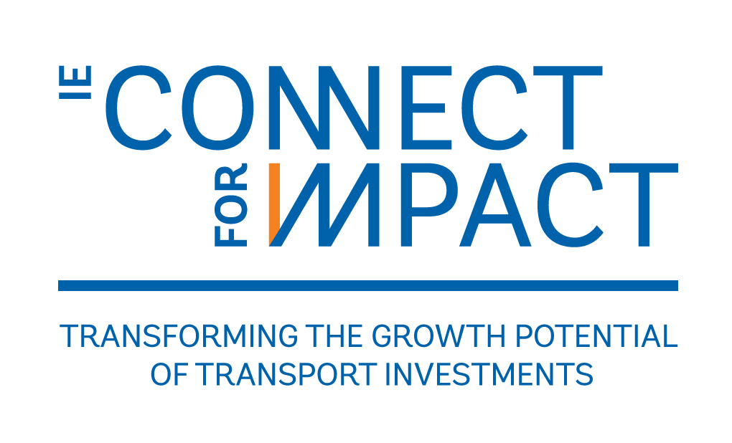

**Measuring and Enhancing Mobility in Dakar**

Senegal

P166486

April 15, 2018

**Keywords: [1]** H54, R41, R42.[2] **(R)**

**Table of Contents**

IE Profile Indicators 4

ieConnect Indicators 5

1. Executive Summary 6

2. Background and Key Institutional Features 7

3. Description of the Intervention 8

4. Literature Review (E) 10

5. Policy Relevance 14

6. Theory of Change (E) 16

7. Hypotheses/Evaluation Questions (E,R) 19

8. Evaluation Design and Analysis (E,R) 20

8.1 Evaluation Design 1: BRT and TER Impact 20

8.2 Fare Structure Experiment 21

8.3 Sample Size Calculations 23

9. Data Collection and Management (E,R) 25

9.1 Main Outcomes of Interest (E,R) 25

9.2 Quantitative Instruments 26

9.2.1 Air Quality 26

9.2.2 Housing Prices and Building Changes 27

9.2.4 Mobility and Long-term Relocation 28

9.2.5 Congestion and Traffic 31

9.2.6 Road Safety Data 31

9.2.7 Public Transit Data 32

9.2.8 Preliminary Analysis for Fare Experiment 32

9.2.3 Survey Data Collection 36

9.3 Data Coding, Entry, and Editing (E) 36

9.4 Management of Data Quality 36

9.5 Ethical Issues 37

9.6 IE Implementation Monitoring System (R) 38

10. Study Limitations and Risks (E) 38

11. IE Management (E,R) 39

11.1 Evaluation Team and Main Counterparts 39

11.2 Work Plan and Deliverables 40

11.3 Budget 40

12. Plan for Using Data and Evidence from the Study 41

References 41

Appendix 48

Air Quality 48

Road Safety 49

Public Transit Data 50

Measuring Mobility 51

# IE Profile Indicators

|  |  |  |
| --- | --- | --- |
| No. | Indicator | Description |
| 1 | IE code | [P166486](http://operationsportal.worldbank.org/secure/P166486/home) |
| 2 | IE Title | Measuring and Enhancing Mobility in Dakar |
| 3 | IE TTL | Sveta Milusheva |
| 4 | IE Contact Person | DIME |
| 5 | Region | AFR |
| 6 | Sector Board/Global Practice | TDD |
| 7 | WBG PID (if IE is evaluating a WBG operation) | [P156186](http://operationsportal.worldbank.org/secure/P156186/home) |
| 8 | WBG Project Name  (if IE is evaluating a WBG operation) | Dakar Bus Rapid Transit Pilot Project |
| 9 | Associated with another IE (Yes, No) | Yes, same P code |
| 10 | Project TTL (if IE is evaluating a WBG operation) | Franck Taillandier |
| 11 | Intervention | Construction of TER and BRT |
| 12 | Main Outcomes | Mobility, accessibility, economic well-being, gentrification |
| 13 | IE Unit of Intervention/Randomization | Individual |
| 14 | Number of IE Units of Intervention | 2,400 people |
| 15 | IE Unit of Analysis | Individual |
| 16 | Number of IE Units of Analysis | 2,400 |
| 17 | Number of Treatment Arms or Iterative Experiments | 3 |
| 18 | IE Question 1 (Treatment Arm 1) | What is the impact of changing fare structure on accessibility, mobility and economic well-being, especially for disadvantaged groups? |
| 19 | Method IE Question 1 | Random assignment at the individual smartcard level |
| 20 | Mechanism tested in IE Question 1 | Constraints |
| 21 | IE Question 2 (Treatment Arm 2) | What is the impact of free transfers on accessibility, mobility and economic well-being, especially for disadvantaged groups? |
| 22 | Method IE Question 2 | Random assignment at the individual smartcard level |
| 23 | Mechanism tested in IE Question 2 | Constraints |
| 24 | IE Question 3 (Treatment Arm 3) | What is the impact of a subsidized fare, equivalent to the subsidy received through treatment arm 1? |
| 25 | Method IE Question 3 | Random assignment at the individual level |
| 26 | Mechanism tested in IE Question 3 | Constraints |
| 27 | Gender-specific treatment (Yes, No) | Yes |
| 28 | Gender analysis (Yes, No) | Yes |
| 29 | IE Team & Affiliations | Aiga Stokenberga and Sveta Milusheva (World Bank), Amadou Boly (African Development Bank), Martina Kirchberger and Carol Newman (Trinity College Dublin), and Pascal Jaupart (University of Oxford) |
| 30 | Estimated Budget (including research time) | Total in USD $1,106,118 |
| 31 | CN Review Date | By August 2018 |
| 32 | Estimated Timeframe for IE | June 2018-December 2021 |
| 33 | Main Local Counterpart Institution(s) | CETUD and APIX |
| 34 | Other Sources of Funding (Yes, No) | Not yet, but may be able to get funding from AfDB and IsDB upon approval of CN |

# ieConnect Indicators

|  |  |  |
| --- | --- | --- |
| No. | Indicator | Description |
| 35 | Subsector(s) | Urban Mobility |
| 36 | MDBs or Bilaterals Involved | Yes – AfDB and IsDB |
| 37 | Data Infrastructure (Yes, No) | Yes |
| 38 | Measurement Framework (Yes, No) | Yes |
| 39 | Female Economic Empowerment (Yes, No) | Yes |
| 40 | Results disaggregated by sex and age (Yes, No) | Yes |
| 41 | Cofinanced Program (Yes, No, N/A) | Yes |

# Executive Summary

Geographical disconnect and inefficient, low-capacity public transport negatively affect the poor, cutting them off from market opportunities. Given the importance of connectivity and mobility, policymakers have begun to explore mass transit systems. Such large infrastructure projects can have both positive and negative effects. Potential positive effects (including decreases in pollution and reductions in road traffic injuries) are important to measure in order to make sure cost effectiveness analyses capture the full benefits which can feed into policy makers’ decision to expand such transit systems. Yet, it is just as important to study negative consequences, such as changes in housing prices that negatively affect lower income individuals, so that they can be countered with complementary interventions. Moreover, solely expanding the transport system does not ensure that marginalized groups will be able to take advantage of it. While public transit is usually presumed to benefit all, often mobility does not increase for certain groups, especially women and low-income individuals.

We aim to study these areas within the context of Dakar, Senegal, where two flagship transportation projects are being built: a Bus Rapid Transit System (BRT) and an Express Train (TER) that will fundamentally transform the Greater Dakar Area. We want to build an extensive data system in collaboration with the Executive Council of Urban Transport in Dakar (CETUD) that will enable us to study the effect of these systems on a number of indicators in Dakar. We also want to study how the fare structure of these systems can be developed to enable marginalized populations, especially women, to benefit from these investments.

The data system will harness existing data that is already being collected (data on air quality and housing prices), leverage new types of data (mobile phone data and smartcard data to track mobility and satellite images to measure changes in buildings), and combine this with traditional household surveys. While this is a complicated undertaking, including a large number of inputs, we have a large team of researchers with experience using these kind of data, and the full support of CETUD, which has the capacity to bring together data in one place not only for this impact evaluation, but also for planning future transport policies. We will use this data in a difference-in-differences design to understand the impact of the BRT and the TER. The high frequency nature of the data will allow us to extensively control for trends and improve on the typical difference-in-differences specification. To study improving access to these new transport systems for marginalized groups, we will use a more traditional experimental design to test how changing the structure of fares and/or changing rules regarding transfers can affect access. The smartcard technology that will be used for both the BRT and the TER will allow us to implement the experiment (assigning different fare structures to different individuals) and will also help us track mobility of users to measure the impact.

Given that the two projects we are evaluating are flagship projects for Senegal, the impact evaluation will be critical for these agencies to understand the impact of these large investments. More importantly, it will provide evidence on how these investments can be further leveraged and scaled up in the coming years to increase their impact, as well as evidence on how to increase accessibility for marginalized groups in these and future projects. It will also help provide evidence that can be used by other developing countries looking to improve the mobility and well-being of their growing urban populations.

# Background and Key Institutional Features

Urban areas were home to about 54% of the global population in 2015 and this proportion is expected to keep increasing to around 70% by 2050. With rapid urbanization, growing congestion challenges have led policymakers to look for solutions based in public transit. Good connectivity and efficient mobility create economic opportunities, encourage social integration, and facilitate access to markets and services. By promoting economic growth that increases labor market opportunities for the poor, connectivity improvements can be a powerful element of broader poverty alleviation programs (World Bank, 2007). Transport can play a pivotal role in poverty reduction both indirectly, through economic growth, and directly, through its impact on the mobility needs of the poor (Faiz, 2011). Lack of connectivity in African cities is an important factor constraining the inclusion of the poor in the growth process. Geographical disconnect and inefficient, low-capacity public transport negatively affect the poor, cutting them off from market opportunities. The poor predominantly work in low-productive micro informal firms, often located on the outskirts of cities, suffering from poor physical access to employment opportunities and services. Given the importance of connectivity and mobility, policymakers have begun to explore mass transit systems - fast, high-capacity, high frequency, and large-scale transport modes. These systems include rail-based systems such as Mass Rapid Transit (MRT or Metro), Light Rapid Transit (LRT or ‘tram’), and Bus Rapid Transit (BRT).

The Government of Senegal (GoS) has recognized that improving urban mobility in the Greater Dakar Area (GDA) is of crucial importance for the development of the Senegalese economy. Within an area of 550 km2, there were 3.5 million people in 2017—expected to rise to 5 million in 2030—representing 23% of the country’s population and 50% of the urban population. To help promote mobility among this vast population, the GoS has adopted a comprehensive 5-year plan to address some of the challenges that the sector faces. This plan highlights the need to develop an efficient mass transport system, offering a high level of speed, comfort, and safety. Two flagship projects of this plan, with strong presidential support, are: i) a modern bus transport system with high level of service (BRT) linking the city centre to the north of the city and ii) the development of a railway express line (TER) linking the city centre to the south of the city.

Such large infrastructure projects can have both positive and negative effects. Potential positive effects (including decreases in pollution and reductions in road traffic injuries) are important to measure in order to make sure cost effectiveness analyses capture the full benefits which can feed into policy makers’ decision to expand such transit systems. Yet, it is just as important to study negative consequences in the form of population displacement and changes in housing prices that negatively affect lower income individuals, so that policy makers can try to counter some of these negative effects with additional interventions. This IE project aims to conduct a systematic analysis of the impact of the BRT and TER systems on urban mobility and commuting patterns; congestion and air quality; housing prices and gentrification; road safety and road traffic injuries.

Moreover, solely expanding the transport system does not ensure that marginalized groups will be able to take advantage of it. While public transit is usually presumed to benefit all, often mobility does not increase for certain groups, especially women and socio-economically disadvantaged individuals who are unable to afford the transit fare, whose daily mobility patterns are not conducive to using public transport, or who face other factors that prevent them from being able to utilize the public transit system. For example, there is research showing that women tend to make more trips to perform household-sustaining activities such as shopping or family errands, doing more of what is known as “trip-chaining,” where they make several stops for different errands (McGuckin and Murakami 2014). This “trip-chaining” is then likely to determine the mode choice (Ye et al 2007). In a system where there is a flat rate to use the public transit no matter how far you go and every time you change buses, women who have to make multiple short stops will incur a cost that is often too high to make use of public transit feasible. Similarly, lower income individuals are often part of the informal sector that can have very different transit patterns requiring multiple short stops.

Differentiated fares have been advocated not only from an economic efficiency but also equity perspective: passengers tend to perceive a fare structure to be ‘fair’ when it establishes a strong relationship between the distance travelled and fare levels (Streeting and Charles 2006), and differentiated fares reduce the cross-subsidization of long distance passengers by short distance travelers (Cervero and Wachs 1982). Technological advances such as automatic fare collection systems have paved the way for implementing distance-based fare structures in many cities (Bandegani and Akbarzadeh 2016; Luhrsen and Taylor 1997). This IE will help build the knowledge base on the effectiveness of differentiated fares in a developing country setting to increase transit use overall and by marginalized groups in particular.

# Description of the Intervention

The main intervention is the building of the Bus Rapid Transit system and the Express Train in Dakar, which aim to increase urban mobility within the Greater Dakar Area. Construction of the TER began in 2017 and will finish in January 2019. Construction of the BRT will begin in January 2019 and includes the integration of feeder bus lines into the new system. The top of Figure 1 shows the exact location of the new lines. The red line shows the first BRT line that will be built. The gray line shows the first part of the TER that is currently being built. The two green lines show additional BRT lines that are planned for later phases. There are plans to extend the length of the TER to continue to the new airport. The bottom of Figure 1 shows the complete length of the TER, including both the first phase currently being built (Dakar to Diamniadio) and extending to Blaise Diagne International Airport (red line). The length of the BRT is 18.3km and the length of the TER is 36 km to Diamniadio and 55 km to AIBD. Travel time along the full length of the BRT is expected to be reduced from 95 min to 45 min and improvements in both pollution and road safety are expected.

This IE project aims to put in place a Data System in Dakar that will allow a systematic analysis of the impact of these two large transport infrastructures on urban mobility and commuting patterns; congestion and air quality; housing prices and gentrification; and road safety.

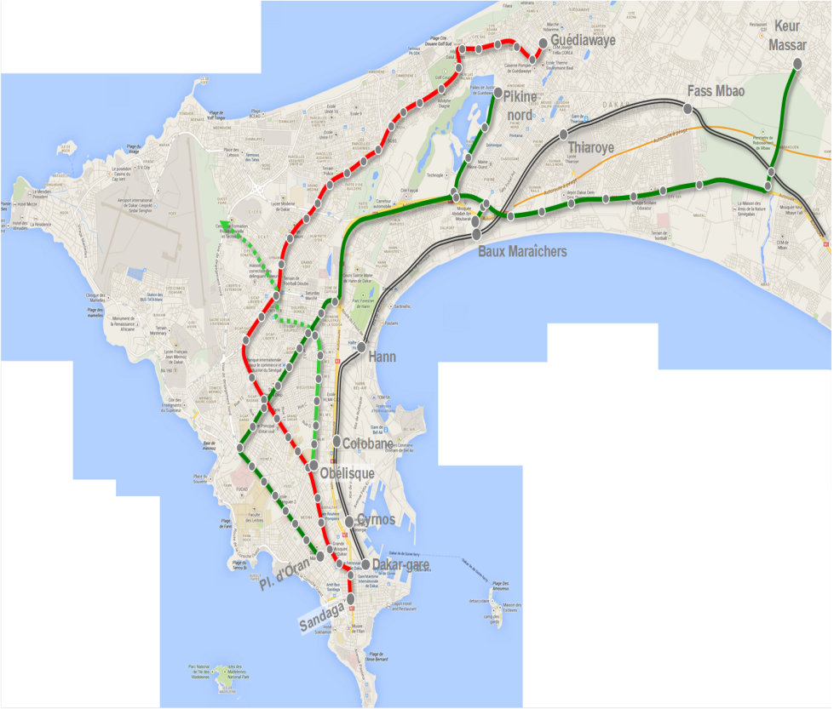 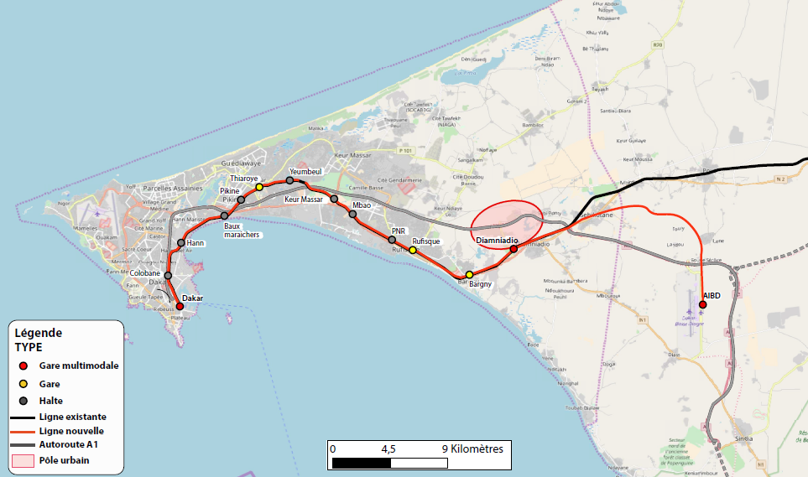

Figure Maps of BRT AND TER LINES

A complementary intervention will be studied to understand the impact of alternative fare structures on the use of the new transit system and on ridership by women and socio-economically disadvantaged groups in particular. We will conduct a randomized control trial to test different fare structures. Both the BRT and TER plan to use smartcards. The use of these cards will make it possible to apply different fare structures for different individuals. There will be three treatment arms and a control group. The control group will be given a smart card and will have to pay the standard fare, which consists of a flat rate paid no matter how far an individual travels. The three treatment groups will be given three different types of smartcards: (i) one will consist of charging a fare based on the distance of the trip; (ii) the second will charge the user a flat rate but will allow free ridership transfers within a 60 minute period; (iii) the third will charge a flat discounted rate, with the discount calibrated to the expected discount received from the distance-based fare. For the group that will pay a fare based on the distance, the cost of one trip will never exceed the flat rate paid by the control group. To give an example for the second treatment arm: a person who takes the BRT, runs a short errand and takes the BRT back would only pay for one fare if the time between the beginning of the first and the beginning of the second trip is less than 60 minutes. The third arm is included in order to help us separate the income effect from the effect of the different fare structure.

# Literature Review (E)

Several studies based in developing country cities have uncovered various impacts of BRT systems related to issues such as urban mobility, road safety, air pollution, land value, and gentrification; mainly focusing on Latin America and Asia. Existing evidence shows a positive impact of BRT systems on mobility. Based on BRT systems in 11 cities in Latin America and Asia, Hildalgo and Graftieaux (2008) find that average traffic speeds increased by between 15 km per hour (kph) and 26 kph after transforming a regular service into BRT. Putting in place a BRT system also increases car speed in regular traffic but less than that of buses, making BRT more time competitive than cars (Cervero and Kang, 2011). Yazici et al. (2013) show that the 2007 implementation of Istanbul’s Metrobus removed about 1,300 private minibuses from the road; and led to an average daily time savings of 52 minutes for those who switched from minibus to BRT. Decreased traffic and congestion can also reduce polluting emissions as shown by Bel and Holst (2018) for Mexico City.

Regarding road safety, the BRT in Bogotá is credited with an estimated 88 percent reduction in traffic fatalities (mostly pedestrian deaths) on TransMilenio corridors thanks to complementary road safety improvements (Hidalgo and Yepes, 2005; Hidalgo et al., 2013). Likewise, in Istanbul, BRT and the induced removal of minibuses from traffic resulted in a 64 percent reduction in bus accidents in one year along the corridor (Yazici et al., 2013).

In Seoul, Cervero and Kang (2011) show that BRT improvements prompted property owners to convert single-family residences to higher density apartments and condominiums; and land prices increased by up to 10% within 300 m of BRT stops and non-residential land values gained premiums of up to 26% within 150 m. Yet, increases in land values can sometimes lead to gentrification as in Colombia, where Pfutze, Rodriguez Castelan, and Valderrama Gonzalez (2018) find that, in proximity to newly opened stations, poor households were replaced by households in the middle and upper socioeconomic strata. The BRT system in Bogota also led to higher population density in some served areas compared to areas without access, particularly those in the periphery that were provided with feeder bus routes (Bocarejo, Portilla, and Pérez, 2013). In her review, Stokenberga (2014) finds that the land-use and value impacts of BRT systems have been less uniform across systems compared to performance metrics such as speed and travel time. Such a result is partly explained by the primary use of cross-sectional modeling techniques, which make it difficult to establish causality; and this remark can be extended to most previous studies on the BRT impacts. The review therefore highlights the need for more rigorous evaluations of the impact of BRT systems, particularly on land value and related gentrification.

Due to the rising incomes in developing countries and increasing private motorization, it is also not easy to predict in advance how strongly, if at all, the new mass transit systems will impact environmental and congestion outcomes. As the fastest urbanizing continent, African cities are increasingly considering new mass transit systems such as BRT or rail-based systems to tackle traffic and congestion challenges. While previous research has mainly focused on Latin America and Asia, city inherent characteristics, specific system characteristics, local property market properties, general and regional economic conditions, population density and policy objectives may affect the impacts of BRT systems in Africa cities, differently from those in Latin America and Asia. It is therefore imperative to empirically measure and correctly attribute the impacts of new mass transit systems, not only from a policy prioritization point of view, but also for improving the analytical validity of project-level analyses. For instance, it is important to ensure that the purported environmental benefits of mass transit projects are not overestimated and the indirect gentrification and other negative social impacts are not undervalued or altogether ignored. The proposed IE will contribute to the understanding of the broader mobility patterns and their impacts on the housing market, access to services, and environmental outcomes, specifically in the context of a rapidly growing and motorizing city in Africa.

To best of our knowledge, the ongoing Dar-es-Salam BRT Impact Evaluation is the only one of its kind in Africa. It aims to examine the effects of the BRT on outcomes such as mobility patterns, cost and access to transport, women’s safety, security in public transport, and land development. In the same vein, our proposed IE will contribute to the understanding of the broader mobility patterns and their impacts on the housing market, access to services, and environmental outcomes in Dakar, a rapidly growing and motorizing city in West Africa. Our study has a number of distinctive features that distinguish its approach from that of the Dar es Salaam study. First, we are planning to evaluate both a BRT line and Railway Express line. As a bus service can be generally perceived as being less permanent than a rail service, a BRT system can have lower impact on land value than a rail-based system (Rodríguez and Targa, 2004). As our study includes both a BRT and a Railway Express component, we will be in a position to compare their relative impact on land value and land use. Second, we are planning to develop a data system that will allow a systematic analysis of the impact of large scale transport infrastructure on a “continuous” basis; including the scaling up of the BRT lines. Finally, experience from other cities shows that solely expanding the transport system does not ensure that marginalized groups will be able to take advantage of it. Our study will address this issue by providing insights as to what transit fare structures are more likely to incentivize ridership by the poor and other marginalized groups.

Turning to the fare experiment, an extensive economic literature addresses mass transit fare levels. Studies of fare elasticity have found that short-run price elasticity ranges from -0.2 to -0.8, and that long-run elasticity can be up to twice as large (e.g., Abrate et al. 2009). Price elasticity has been found to be higher for suburban service compared to urban service (e.g. Nijkamp and Pepping 1998) and for single tickets compared to multiride tickets (De Rus 1990; Dargay and Pekkarinen 1997). Most existing research finds that peak period riders, long-distance passengers, commuters, and “captive” riders without travel alternatives – such as the poor – are less responsive to fare changes than others (TRB 2004; Sirikijpanichkul and Winyoopadit 2013; Wardman and Grant-Muller 2011). In individual cases, however, low-income riders are more likely to reduce their travel when fares are increased, likely due to more constrained personal budgets (Miller and Savage 2017). Youth have been found to have higher sensitivity to fares, presumably because of lower incomes (Mayworm et al. 1980). Reviews on elasticity of transit demand in relation to fare change and other level-of-service variables are provided by Paulley et al. (2006) and Pratt et al. (2000).

Much of the data on rider response to transit pricing applies to general fare level changes, not to changes in fare structure (TRB 2004). However, the literature that does address fare structure impacts tends to show that differentiated fares increase ridership. A new integrated fare system introduced in Haifa, Israel, in 2008, incorporated a zone-based, origin-destination, time-based fare, with unlimited transfers within a period of one hour. Using fare-box data, on-board surveys and travel-behavior model estimation, Sharaby and Shiftan (2012) showed that the new fare policy resulted in an increase of 8% in passenger trips, and that passengers actively took advantage of the free transfer option to enjoy a wider range of routes. Zhang et al. (2017) investigated the effects of the change in Beijing’s transit fare policy in 2014 from a flat to a distance-based fare. Using stated preference surveys of passengers at subway stations, they found that lower-income passengers and long-distance commuters were less satisfied with the new system than others. However, while the new policy made the ridership decrease sharply in the first month, it gradually came back to the previous level four months later. Luhrsen and Taylor (1997) have argued that differentiated pricing lowers fares, and thus increases demand, for less-expensive-to-provide service – during the off-peak and for short trips.

Existing research has evaluated the role of transportation in social exclusion and social equity (e.g. Boschmann and Kwan 2008). However, fewer authors have looked at equity aspects of transit fare policies (Bueno Cadena et al 2016; Nuworsoo et al. 2009). Passengers’ income level, age, gender, and profession indirectly influence fare equity through different choices of travel distance and boarding time (Cheng et al. 2016). Flat fare systems have quite universally been found to favor long-distance commuters by giving them the least cost per mile (Pratt et al. 1977). Since in U.S. cities low-income residents tend to live in central city neighborhoods well-served by transit (Glaeser et al. 2008), these residents likely travel shorter distances and thus are poorly served by flat fares (Verbich and El-Geneidy 2016). Studies by Nuworsoo et al. (2009), Deakin and Harvey (1996), Cervero (1982), and Ballou and Mohan (1981) all found that flat fares most negatively impact vulnerable populations (youth, low-income individuals) due to their more frequent use of transit, shorter travel distances, and tendency to travel disproportionally during non-rush hours (Cervero 1981). Nuworsoo et al. (2009)’s study showed that proposals for flat fares were the least equitable even when the base fare was lowered. Farber et al. (2014), in a study of the social equity impacts of a switch to distance-based public transit fares in Utah, found that, overall, distance-based fares benefit low-income, elderly, and non-white populations; however, the effect is geographically uneven and may be negative for members of these groups living on the urban fringe. Liu et al. (2017), through a series of numerical simulations focusing on Chinese cities, found that all the considered differential fare strategies performed better at enhancing social welfare compared to the flat fare strategy. Bocarejo and Oviedo (2012), in a study of the Bogota’s BRT system, showed that the fare policy can have a greater equity impact than the expansion of the network. Finally, differential fares have been found to not only be more equitable but to also provide the greatest benefits in terms of increasing the operator's revenue (e.g. Johnson and Ford 2013; Borndoerfer et al. 2012; Chien and Tsai 2007; Ling 1998).

To maximize the effect of transportation spending on development, policy makers need to understand the constraints that all individuals and households face in using transportation (TRB 2011). While there is recent evidence from urban metropolitan areas of a convergence of men’s and women’s transit modal shares (Pisarski 2006; Pucher and Renne 2003), important gender differences are still observed (Handy 2006; Rosenbloom 2000; TRB 2011). Nobis and Lenz (2006), Odufuwa (2005), Al-Kazily et al. (1994), Rosenbloom (1987), Hanson and Johnston (1985), Michelson (1983), and Skinner and Borlaug (1980) have found that women tend to travel shorter distances, including specifically for work trips, but to undertake a larger number of trips per day. Existing research also finds that women are more likely to use public transit for trip purposes other than commuting (Kuhnimhof et al. 2006; Gordon et al. 1989), and that complexity of trip chains is typically higher for women than men (Rosenbloom 2005; McGuckin and Srinivasan 2003;), especially when their children are young (Al-Kazily et al. 1994; Strathman and Dueker 1994; Rosenbloom 1989). The latter is because women are not only earners, but also child care providers, household managers, and, often, maintainers of community and social networks (Moser 1993). Importantly, women have been found to have access to fewer transport choices, making it prohibitive for them to work far from home (TRB 2011; Srinivasan 2005), and to spend a larger share of income on public transport – as much as 29%, according to a study in Kampala, Uganda (Kamuhanda and Schmidt 2009).

The literature search did not return any completed examples of the use of experimental methods – in particular, random assignment of fare structures – in the evaluation of fare structure impacts. Banerjee and Sequeira (2014) have ongoing work that experiments with subsidized fares, but it is focused on providing free fares to job seekers to look at employment outcomes. We build on this type of work by looking at different fare structures, rather than purely subsidizing, and looking more generally at accessibility rather than focusing only on employment. Additionally, the majority of existing research is focused on developed country settings, which can differ significantly from our setting in Senegal. This IE would contribute to these literatures through experimental evidence that would provide causal estimates in a developing country setting.

# Policy Relevance

Given that the two projects we are evaluating are flagship projects of the country’s 5-year plan, they have so far received great support from government agencies. The impact evaluation will therefore be critical for these agencies to understand the impact of these large investments and more importantly, to provide evidence on how these investments can be further leveraged and scaled up in the coming years to increase their impact. For example, studying the displacement impacts is important for developing complementary policies, such as density bonuses for developers who allocate part of the land to affordable housing construction, which can help mitigate negative impacts of these investments. A better understanding of the housing price impacts, on the other hand, can inform future land value capture (LVC) policies targeting the key transit corridors. As infrastructure funding requirement grows in many African countries, the use of LVC tools will become increasingly important, enabling the capture of a share or all of the increase in private land value that results from BRT investments and providing an additional source of funding for the construction and maintenance of the transit systems. Relatedly, as fast-growing African cities are considering new mass transit systems such as BRT or rail-based systems to tackle traffic and congestion challenges, our study can give policy-makers actionable evidence on the impacts that can be expected from implementation of such infrastructure investments and how to capitalize on these investments to achieve even better development outcomes.

Additionally, this IE project aims to put in place a Data System in Dakar that will allow a systematic and “continuous” analysis of the impact of large scale transport infrastructure on urban mobility and commuting patterns; congestion and air quality; housing prices and gentrification; and road traffic injuries. Given the system will be established in collaboration with CETUD and housed there (and has the strong backing of CETUD’s director), we believe that the system will be maintained after the end of the IE. We will aim to build the system in a way that data collection is automatized, in order to reduce maintenance requirements. This Data System will add a strong sustainability element to the project as it will remain available for use by government agencies for evidence-informed policy making in the years to come. The Data System can also act as a model for other countries in how data can be integrated and applied by policymakers to achieve better results.

Ensuring equal access to quality public transportation for all groups is an essential feature of a sustainable and inclusive transportation system. This IE will help build the knowledge base on what additional policies are necessary to increase ridership by marginalized groups. The results of this IE can help policy makers in Senegal in deciding on a fare system that is conducive to equitable access and increased mobility for all. Given that all transit system users will have these smartcards in order to access the system, it will be possible to scale up the pilot to the level of the city’s overall transit system if we find a pareto-efficient fare schedule that successfully increases the mobility of marginalized groups.

This project is in partnership with the African Development Bank and the Islamic Development Bank, which are sister MDBs seeking to promote the use of IE to improve their operations. As such, it is part of the World Bank drive to promote evidence informed development projects through the use of rigorous impact evaluations across institutions. The IE could have a large influence on policy, since results will be disseminated across these three major development institutions and the relevant project teams within them. Additionally, by demonstrating how impact evaluation can be conducted across institutions, the evaluation can help influence how IE is done more generally, focusing on a programmatic approach rather than a project specific one, which in the case of transportation evaluations is critical given the large scale of the infrastructure works and the associated capital investments that often require funding from a number of actors.

We will track our policy influence by first seeing any changes related to the implementation of the second phases of both the BRT and the TER that demonstrate adoption of the policy recommendations generated by the evaluation. For example, if we find that there is gentrification and it has a negative impact on lower socioeconomic groups, future phases may implement additional safeguards to decrease this negative impact. We will also track the type of fare structure that is adopted by both the BRT and the TER and how it relates to the findings from our experiment. We will also look at the maintenance and use of the Data System by government officials for purposes of planning and better understanding the urban environment. We will incorporate the clients during all stages of the project, building capacity to maintain and use the data system and discussing results from all stages in order to provide evidence relevant for them. Additionally, we will disseminate results more broadly to wider policy audiences, and will track if policy participants at these dissemination events then incorporate the evidence and research into their own infrastructure investment planning.

# Theory of Change (E)

The main intervention this impact evaluation aims to study is the commissioning of the Dakar Bus Rapid Transit (BRT) system and the Express Regional Train (TER). These new public transportation types will affect city residents as well as a broad range of economic, social, and environmental outcomes. The causal logic of why and how the BRT and TER will impact these outcomes is described below and summarized in the theory of change’s results chain (see Figure 2).

The most immediate effect of the intervention will be to reduce transportation costs and encourage public transit ridership. This will allow greater urban mobility within the city of Dakar with residents having a greater capacity to access opportunities in various parts of the city and at a lower cost. Urban dwellers will have better access to amenities, public and private goods and services. For example, the Dakar Urban Accessibility Analysis conducted using geo-spatial modeling software in 2017 as part of the BRT project preparation shows that 60 percent of the city’s population will be able to reach at least one *additional* health center, one additional market, and one additional secondary school as a result of the BRT.

Second, the more efficient urban transport system will reduce frictions in Dakar’s labor market. Job search will be less costly and access to information for firms and potential employees easier. This in turn should lead to superior individual labor market outcomes and earnings, better matching between firms and workers, higher productivity as a consequence, as well as agglomeration economies in the medium to long run. The same Accessibility Analysis referenced above also estimated that the average Dakar resident will be able to physically reach 59 percent of the city’s jobs once the BRT is operational, compared to 52 percent of jobs in the reference scenario.

Third, the introduction of these new and efficient commuting types will make other transportation modes such as private cars or minibuses relatively less attractive. It is expected that commuters will rely less on these modes, which in turn will tend to reduce congestion, pollution, and road traffic accidents (as less motorized vehicles will be on the road along the BRT and TER corridors - and possibly the city as a whole). This is especially true concerning large trucks carrying goods since the TER includes a freight line that will make movement of goods from the port to the rest of the country and into Mali easier since it will no longer be necessary for large trucks to travel through congested Dakar. In the longer run, this will translate in improved air quality and better road safety. All of these impacts detailed so far will imply higher welfare for Dakar’s residents.

Fourth, the change in employment and market access in areas located in the vicinity of BRT bus stops and TER stations will likely experience increased local demand for land and housing. This ought to materialize in higher land and property prices in the short to medium run, and a different neighborhood composition in terms of households and firms in the longer run. Given that one of the primary objectives of the intervention is to improve access to transportation to working class and marginalized households, the gentrification of neighborhoods connected to the BRT and TER would be counterproductive. It is therefore of crucial importance to monitor this set of outcomes.

The above-mentioned impacts are quite likely to be heterogeneous across individual characteristics and geographical location. In particular, a lot of the causal logic discussed thus far assumes that individuals will have the capacity to access the new train and bus services. However, in a worst-case scenario, marginalized populations might be priced out and not able to benefit from the new transit modes, while upper class households might not be willing to ride public transport modes and prefer the use of their own cars.

The ridership of poor households is of higher interest to the policymaker. To better understand the commuting patterns and choices of the urban poor and assess potential options to improve the extent to which they benefit from the BRT and TER, we will run a second intervention. We will run a randomized controlled trial to understand what type of fare structure might be able to stimulate ridership the most. We will also measure the access to goods and services and labor market outcomes of study participants. This intervention will take advantage of the smartcard system both the BRT and TER will rely on to introduce three different types of tariffs for a randomly selected group of individuals.

The first type will allow the fare to be dependent on the distance travelled. Population groups who tend to take shorter trips would have an incentive to increase ridership. The second will keep the control group’s flat rate but allow for a 60-minute transfer window between different modes. Population groups that trip-chain (conducting several different tasks on the same trip), are likely to increase ridership. In both bases, based on data described below in section 9, while everyone may benefit to some extent, we believe women may benefit more because they are more likely to conduct multiple, shorter trips for different errands. The third fare will be a discounted flat fare. We expect everyone to benefit from this, and it will be used to help separate the effect of a pure discount from the actual change in fare structure in the other two cases. We also expect that the most socio-economically disadvantaged may benefit more because they will be able to increase their mobility if they are currently foregoing trips because they are too expensive. This experiment will provide important information to policy makers with respect to measures that can increase ridership and experimental estimates of its socio-economic impact.

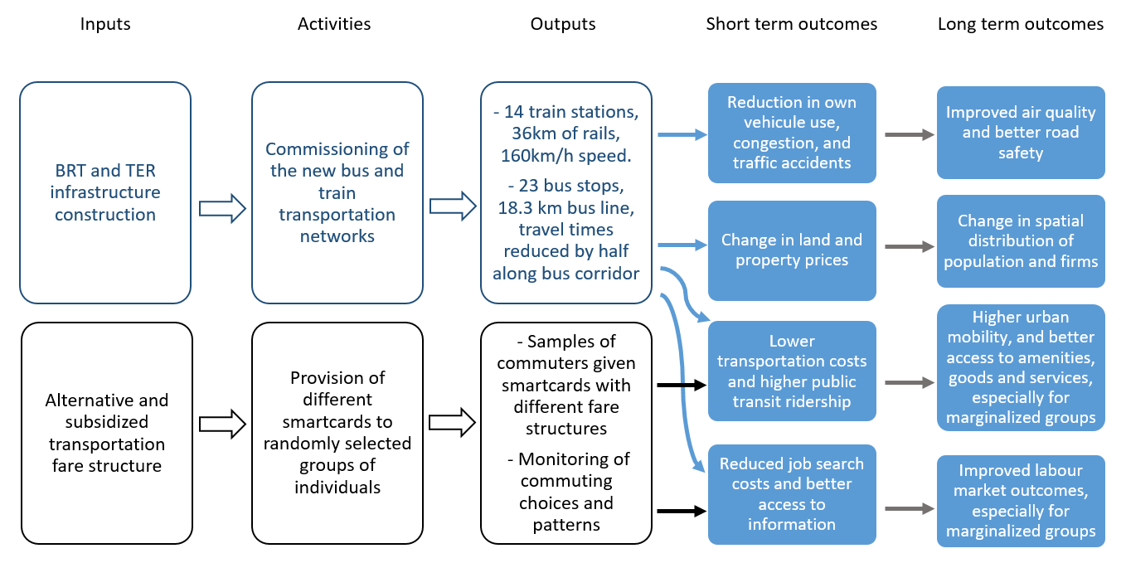

Figure Theory of change

# Hypotheses/Evaluation Questions (E,R)

The theory of change’s causal pathway shows how through the reduction in transportation costs and improvement in accessibility, the BRT and TER are expected to affect numerous individual and socio-economic outcomes. These include reductions in congestion, pollution, traffic accidents, and transportation costs and increases in urban mobility, accessibility, labor market outcomes, and land values. Additionally, based on the theory of change for the fare experiment, we should see higher mobility for women and lower income groups that are provided with the alternative fares and these should lead to improved accessibility to amenities, services, and job opportunities.

In line with our theoretical expectations, we have two primary questions that we plan to study with this impact evaluation, with several components under each one:

**Primary question 1:** What are the effects of the BRT and TER on individuals, the environment, neighborhood composition, and road safety?

Specifically, we will look at the following vector of outcomes:

* 1. Number of cars and trucks carrying goods on the road and congestion more broadly
  2. Mobility and accessibility to social services and jobs
  3. Air quality, based on daily and weekly measures of ambient air quality
  4. Housing prices, gentrification and population composition of neighborhoods (in the catchment areas of the BRT and the TER and control areas)
  5. Road safety, measured by the number of road crashes and road traffic injuries

**Primary question 2:** What is the effect of alternative fare structures on transit ridership overall and ridership among women and socio-economically disadvantaged groups in particular?

More precisely, our three treatment arms will allow us to answer the following questions:

1. Do distance-based fares encourage BRT transit ridership more than flat fares and does this lead to medium-term effects such as increases in labor force participation and wages?
2. Does a 60 min transfer time interval (where transfers are allowed both within and between the BRT, feeder bus and TER systems following ticket/card validation) increase ridership?
3. Do distance-based fares (and/or free transfers) encourage BRT transit ridership among women and lower socio-economic groups more so than among men and higher socio-economic groups?

These evaluation questions were derived from the results chain and in consultation with our Senegalese government counterparts.

# Evaluation Design and Analysis (E,R)

This section presents the evaluation design of the two related interventions we propose to study. We begin with the measurement of the impact of the BRT and TER on economic, environmental and social outcomes. We then describe the research design of the fare structure experiment.

## Evaluation Design 1: BRT and TER Impact

The research design at the core of our evaluation of the impacts of the BRT and TER services is a difference-in-differences (or double difference) model. Our theory of change makes it clear that these interventions will affect several outcomes of different nature and measurement units. Using both traditional survey data and high frequency data, we will compare changes in outcomes over time for areas or individuals located near newly opened bus stops and train stations (the ‘treated’ units) to changes in outcomes for areas or individuals unaffected and/or farther away (the ‘control’ units). Having multiple observations over time for the same units permits us to concentrate on changes in outcomes and difference out all fixed characteristics that differ between treatment and controls and that may be correlated with treatment.

A simple reduced form difference-in-differences model can be specified as follows:

(1)

where i stands for area/neighborhood or individual, t indicates time (day, week, or month), and are coefficients to be estimated. is the outcome variable (for example, pollution, housing prices, or mobility), is a binary variable equal to 1 for units located near new bus stops and train stations, and is a binary variable equal to one for the time periods following the commissioning of the new transport modes. The coefficient of interest is and measures the impact of the intervention on our outcomes of interest. For the sake of simplicity, the treatment is defined here as binary. In practice, we will also use distance from the BRT and TER as treatment.

For this research design to consistently measure intervention impacts, the identification assumption requires that in the absence of these new transit modes, outcomes in the treated and control units would have evolved in a similar fashion (parallel trends assumption). Finding control units that help satisfy this assumption is challenging due to the geography of Dakar (the unique shape of the peninsula it is located on) as well as the layout of the bus and train routes. In order to make this identification assumption as plausible as possible, we will also limit our sample of control units to areas and individuals located near comparable transport routes or planned BRT bus lines scheduled to be opened in later years. While this sample restriction is an improvement in terms of identification, it still doesn’t guarantee that the outcomes of treated and control units would have been on the same trend in the absence of intervention. Particularly worrisome is the selection of the TER and first BRT lines being correlated with unobserved trends affecting outcomes. Nor does this option preclude the possibility of any positive or negative effects ‘spilling over’ from the treated to the control units given the urban planning features of the city.

In an attempt to at least partially remedy these concerns and improve on our identification further, we will follow several additional approaches. Given that for certain outcomes we have sufficiently long time series data before the intervention (for example mobile phone data or pollution), we will assess directly the parallel trends assumption and control for pre-trends if necessary. In addition, we will be able to use this data to perform placebo tests where we will artificially manipulate the timing of interventions. For instance, we will use the high frequency mobile phone data that will give us very detailed information on origins and destinations on a daily basis in order to better control for trends in mobility, which will provide a more robust causal estimate of the impact. In addition, we will compare air quality and congestion at points close to the BRT and TER and far from the BRT and TER, using the daily measures to control for trends and measure the effect from the new transit systems.

Another option is to compare outcomes for areas and individuals located in the vicinity of the BRT and TER lines only. We will here exploit the difference in the timing of the opening of these new modes, which is currently estimated at 18 months (January 2019 for the TER and July 2020 for the BRT). This additional strategy will arguably help to better address spillover concerns and endogeneity issues stemming from unobserved time-varying confounders associated with the selection of transportation lines. The main caveats of this option is that the announcement of the BRT and TER lines and the construction activities may have already affected some of our outcomes of interest. Further, there will be a relatively short time window to observe how outcomes are affected (only between January 2019 and July 2020) and not all outcomes might be quick enough to respond (housing prices for instance).

Triple difference models are not likely to be very helpful in our context. These models compare changes in the ratio of outcomes between areas near the new transport lines and areas farther away to changes in the same ratio in unaffected control areas. Due to the combination of Dakar’s geography, likely spillovers from treated to nearby areas, and the limited physical distance between planned and future BRT lines, it seems quite challenging to find enough treatment and control areas that meet the triple difference model requirements.

## Fare Structure Experiment

Our second evaluation question focusing on the impact of alternative fare structures on ridership will be answered via a randomized experiment. Study participants will be randomly allocated to one of four groups at the start of the evaluation. One fourth of the participants will be provided with a travel card using a distance based fare structure. Another fourth will receive a travel card that allows for free transfers within 60 minutes. The third group will receive a discounted flat fare calibrated to the expected discount received from the distance-based fare. The last group will be the comparison control group. They will receive a free farecard, but it will be the standard card that has no discounts on trips, so that their mobility can be tracked. We will conduct a baseline evaluation of participants prior to providing them with the travel card, and a follow up after four months. In addition, we will collect high frequency data on their transit usage patterns, since each time they use the system with their smartcard, there will be a record of the day, time and location that the card was used. The high frequency smartcard data will allow us to study the intermediate effects on mobility of different fare structures, while the survey will help us to study the medium-term economic effects of increased mobility.

The experiment will be done in two parts. The experiment will first be piloted on a smaller group of individuals using the new TER which will begin operation in 2019. The project plans to conduct a baseline survey prior to the construction of the BRT, which will collect data at the household level. We will use this data to identify the income and gender of individuals in the catchment areas of the TER in order to choose a random sample of individuals. We will stratify by gender (male/female) and by socio-economic status (low income/high income, with exact categories determined based on the baseline data). Within each stratified group, we will randomly assign treatment as follows:

* + 100 people will receive a farecard and a cost-schedule where the cost of trips will vary with distance
  + 100 people will receive a farecard where all of their trips will be discounted
  + 100 people will receive a farecard with the normal flat rate

We do not plan to test the free transfer policy in the pilot since the public transport system will not yet be fully integrated to allow transfers across different modes (this will happen once the BRT is functional). The goal of this small pilot is to test the intervention and finetune it, since the TER will be functional much sooner (especially focusing on the logistics of providing the different discounts and tracking mobility). We will then run a larger experiment once the BRT is operational as well. Approximately 2400 individuals will be recruited to participate. We will again use the baseline survey to identify the income and gender of individuals in the catchment areas of the BRT and TER in order to choose a random sample of individuals. We will stratify by gender (male/female) and by socio-economic status (low income/high income, with exact categories determined based on the baseline data). Within each stratified group, we will randomly assign treatment. For now, we plan to test the three different fare structures already discussed. Depending on the results from the initial experiment on the TER, though, we may modify the treatment, but we will maintain groups of 150 people per treatment.

* + 150 people will receive a farecard and a cost-schedule where the cost of trips will vary with distance
  + 150 people will receive a farecard where the cost will be a flat rate, but they will be able to transfer within 60 minutes of initially using their farecard
  + 150 people will receive a farecard where all of their trips will be discounted
  + 150 people will receive a farecard with the flat rate

The details of this intervention are relatively similar to those of Banerjee and Sequeira (2014) in Johannesburg, South Africa. In that experiment, study participants are allocated to one of three groups (two treatment arms and one control arm) and data collection combine survey questionnaires and smartcard usage data.

Estimates of the treatment effects that take into account stratification can be obtained by estimating Equation 2 by ordinary least squares:

(2)

where refers to one of the three treatments, is a set of dummy variables indicating the individual stratum (or block). The coefficients compare the outcome of treatment group k to the comparison group and are the treatment impact estimates. This design also allows us to assess whether a particular intervention has a larger impact by comparing the estimates with each other. Stratification improves the precision of the estimates and ensures that both in expectation and practice the treatment and control groups are similar along the gender and income dimensions. Blocking is more efficient than controlling ex post for these dimensions, since it ensures an equal proportion of treated and untreated units within each block. With the same proportion of observations being assigned to the treatment and the comparison groups in each block, the average treatment effect of each intervention will be equal to the difference between the outcomes of all treated and all untreated units. Apart from reducing variance, an important reason we adopt a stratified design is because we are interested in the effect of the program on specific subgroups. Finally, the iterative nature of experimenting on the TER first, and then the BRT, will allow us to learn and adapt in order to finetune and develop the right fare strategies to test in order to maximize impact for marginalized groups.

## Sample Size Calculations

Power calculations indicate that this research design will allow for a minimum detectable effect size (MDES) in the range of 0.11-0.16 standard deviations[3] (Figure 3 below). The conservative estimate of a 0.16 MDES assumes a significance level of 0.05, a power of 0.80, 4 blocks, and a sample size of 300 (150 individuals in each group). The 0.11 MDES is based on the additional assumptions that the blocking variable will explain 25% of the variation of the outcome variable, and that the baseline pre-treatment outcome variable will explain 30% of the variation in post-treatment outcomes. We believe that this MDES range is sufficient power.

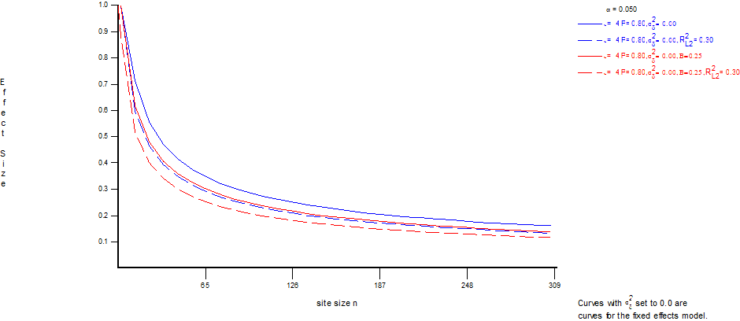

Figure Power Calculations

# Data Collection and Management (E,R)

## Main Outcomes of Interest (E,R)

This IE focuses on measuring how the introduction of two large-scale, efficient mass transit systems influences environmental, mobility, and economic outcomes in a city, and how the pricing of the mass transit services affects transit ridership.

**Table 1. Main Outcomes of Interest**

|  |  |  |  |
| --- | --- | --- | --- |
| Outcome Type | Outcome Name | Definition | Measurement Level |
| Primary/Intermediate |  |  |  |
| Primary | Air Quality | Air Quality Index(AQI) | Daily at the sensor level |
| Primary | Housing Prices | Sale value of property | Individual transaction level |
| Primary | Property conversion | Property conversion from residential to commercial use | Individual transaction level |
| Primary | Long-term relocation | Individuals moving home location to a different neighborhood | Individual level |
| Intermediate | Congestion | Number of vehicles on the road (separated into cars, trucks and busses) passing specific sections of road | Hourly at the road section level |
| Primary | Labor Market Outcomes | Type of employment or work engaged in  Job search and job retention  Weekly hours/days worked and earnings | Individual level |
| Primary | Economic well-being | Monthly spending on food, rent, utilities, transport, schooling, healthcare, and total spending  Ownership of radio, TV, video, bicycle, motorcycle, car, refrigerator, computer, telephone, sewing machine, stove  Building material for exterior walls/floor/roof | Household level |
| Intermediate | Mobility | Number of weekly trips  Number of different locations visited per month  Number of people traveling between neighborhoods  Length of time for different trips | Individual level, neighborhood level, bus route level |
| Primary | Accessibility | Time to reach closest school, hospital, market  Cost to reach closest school, hospital, market  Number of amenities within a 30 min distance | Individual level |
| Primary | Public transport ridership | Ridership for marginalized groups (including women and lower income individuals)  Ridership by mode of public transit | Individual level, bus or train level  Measured weekly at the individual level and daily at the bus level |
| Primary | Road Traffic Crashes | Number of crashes per 100 cars | Daily level by geographic area and eventually by neighborhood |
| Intermediate | Building changes | Physical changes in buildings such as new construction, additional floors added, or other changes as defined using satellite data | Monthly at the parcel level |

## Quantitative Instruments

Given the large scope of the study and the large number of outcomes that we are interested in, we will work with CETUD to develop a new data system. Its objective is to track the evolution of urban mobility and its effects before and after the TER and the BRT become operational. The system will include data to track all of the outcomes listed earlier, including individual mobility (both daily and long-term relocation), pollution, traffic, housing prices, neighborhood socioeconomic composition, crashes, and fatalities from road traffic injuries. This data will provide a comprehensive picture of mobility in Dakar for any given time period and will allow us to evaluate the effects of the new infrastructure on the aforementioned outcomes. We will bring together and make use of both existing data and new data that can be categorized into three main types: primary data collection through household level surveys, secondary data from government institutions, and passively collected data through sensors, satellites, and mobile phones. We will discuss in detail how each outcome will be measured, and include examples of the data and planned analysis where possible.

### 9.2.1 Air Quality

Air quality is measured using static stations in different parts of Dakar. There are five stations that have been present since 2012, and a new station in Guediawaye that has recently been established. The locations of the six stations are shown in Figure 4. Data is available on a daily basis from these stations and includes collection of five major air pollutants: ground-level ozone, particle pollution (particulate matter), carbon monoxide, sulfur dioxide, and nitrogen dioxide. The data collected is used to generate the Air Quality Index (AQI), which runs from 0 to 500. 50 represents good air quality and values below 100 are considered satisfactory, while values above 100 are thought to be unhealthy for sensitive groups and eventually for all groups as the value gets higher. We have already collected the available AQI data from the five stations from 2012 to 2017 (excluding Guediawaye, given it has only been added in 2018), and we will be able to continue collecting this data on an ongoing basis. The Appendix includes figures showing trends in the 2012-2017 data.

In addition to the data available from the six sensors, we will also deploy mobile sensors in order to obtain readings more precisely at various locations around the city and also during different times of the day. This type of data collection has been piloted by the GSM Association in London in partnership with the Royal Borough of Greenwich, where mobile sensors were attached to vehicles that drove around Greenwich during different times and continuously recorded air quality (GSMA 2018). We would do something similar, potentially attaching mobile monitors to some of the busses to measure air quality along particular routes, or using pedestrian enumerators to walk with the devices to record air quality. We will test different methods and determine what works best in terms of quality of data and feasibility.

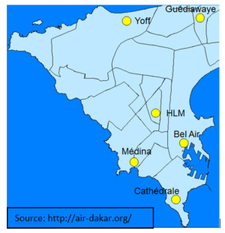

Figure : Location of air quality monitoring stations

### 9.2.2 Housing Prices and Building Changes

Data on housing prices will come from the government land cadaster for all of Greater Dakar, which includes data on all land transactions. This will provide data on the property, its location, and the price at which it was sold. We can obtain this data historically as well as going forward and are able to analyze how prices have changed over time. DIME has an already ongoing relationship with the General Directorate of Taxes and Domains (DGID) which has this land registry data and has agreed to share this data with DIME.

One concern with using land registry data is that there is an incentive for individuals to underreport the prices at which properties are sold. Given we are interested in studying changes in prices across different spatial areas, as long as the level of underreporting is not correlated with the intervention, we should still be able to use the data to measure differential changes in housing prices across areas. Nevertheless, we also plan to collect data from real estate agencies in Dakar that may have more accurate measures of property values and prices. CETUD has included this type of data collection as part of the baseline it plans to collect for the BRT project. We will work with CETUD to collect this data historically and going forward.

To measure building changes, we plan to work with Airbus, which has an ongoing project in Dakar that is part of the International Partnership Programme run by the UK Space Agency. Through this project, they have developed an application that uses detailed satellite imagery to analyze differences between images from different time periods. They use Airbus Pleiades satellite imagery which includes an Orthophoto layer, digital surface model (DSM) layer and digital terrain model (DTM) layer. This is combined with land parcel data in order to analyze both changes in height and in the image.[4] Through this methodology, it is possible for us to evaluate physical changes in buildings that occur across Dakar over time. Figure 5 shows how this kind of analysis can be used to classify changes in buildings.

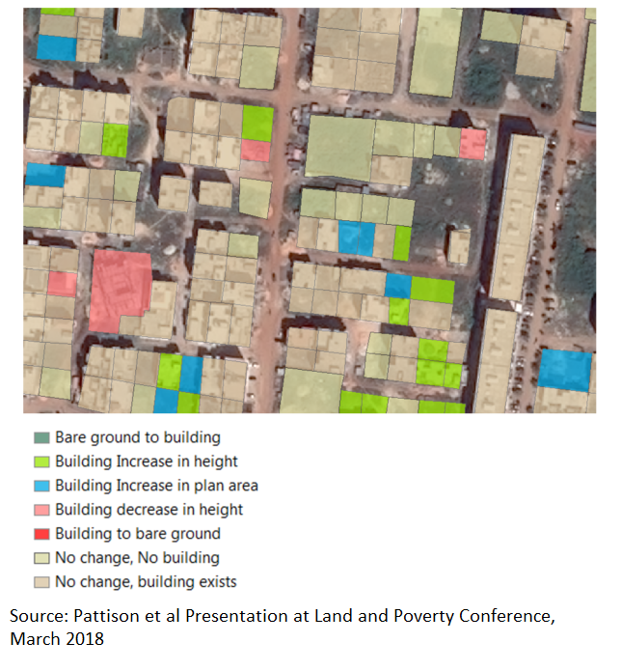

Figure Example of classification of building changes

### 9.2.4 Mobility and Long-term Relocation

For mobility, both daily and long-term relocation, we have two sources of data. The first is going to be the smartcard data which will be collected automatically when individuals use their smartcard to use the new transport systems. The data will allow us to track mobility of individuals on the public transport system over time and at the individual trip level.

The second source of data is more comprehensive because it does not limit us to one mode of travel. We will use mobile phone data collected by Sonatel, the largest mobile phone provider in Senegal. The mobile phone data consists of both Call Detail Records data (CDR) and Probe data. CDR data consists of records of every call and text including an ID that can be tracked across records, the time, and the closest mobile signal tower. It is available going back at least 10 years and is available for every Sonatel SIM card (in 2013 there were over 9.5 million SIM cards and around 15 billion records in Senegal). Probes data is even more detailed, containing not just records for calls and texts but records for any interaction that a mobile phone has with a tower, even if the person is not directly using their phone (for example on smart phones any time apps or email are updated, a record is created). Given this data is much larger, it is kept going only 6 months back. While mobile phone data can be difficult to work with due to the large volume of data that necessitates use of different data storage and programs, two of the researchers on this project have extensive experience working with this type of data in Senegal. This includes working with the raw data located on a Hadoop cluster to create algorithms to study mobility using Hive software. Additionally, the researchers are working closely with Birahim Gueye, a researcher at Sonatel, and two Senegalese students, Dame Ndiaye and Mamadou Cisse, that are working under Birahim.

We have already been working with Birahim and his team on a Proof of Concept to test how the data can be used to study gentrification. We have developed a prototype algorithm which takes one month of data from a specific user, and following Isaacman et al (2011) and Bjorkegren (2015) we identify important locations for users in that month. The algorithm takes the locations of calls and texts and clusters these locations and then provides the centroid of each cluster. Only clusters with enough days are kept, and those clusters are then defined as work or home locations based on a characterization of the calls and texts made from each cluster. For the Proof of Concept we do this for a group of 100,000 users in November 2017 that have had at least one call in Dakar that month, and we follow these users back to July 2017 and define their home location in the same way. We then compare the locations identified as home between July and November to see if a person has relocated during the period between observations.[5] Figure 6 shows the percent of individuals with a home location in a given arrondissement in Dakar that did not have this home location in the July data. This allows us to see areas that are getting a larger influx of people moving in compared to other areas. This is still only a rudimentary algorithm, developed over 4 weeks, and we will refine it during the course of the IE. We discuss these plans and the limitations of the algorithm in detail in the Appendix, along with additional analysis.

The Proof of Concept we did only took two months of data and looked at changes for 100,000 people over the period between the two months, just to show how this kind of analysis could be done. Now that we have developed the algorithm to do this, it only takes time to run the algorithm on the full set of SIMs for the whole country and over a longer period of time. We will also work to refine and improve the algorithm, but even this basic version can provide tremendous amounts of information. Through this methodology, we will be able to study the relocation of individuals over time. We will then be able to compare relocation patterns of individuals living close and far from the BRT/TER for several years both before their construction and after their construction. We will not only be able to tell if people change locations, but we will also be able to study aggregate patterns of movement to understand if there are whole neighborhoods where a large percentage of individuals moved out, where these people moved out to, and where people moving into those neighborhoods are coming from. Finally, mobile phone data has also been used to study poverty and income levels based on characteristics of mobile phone users (Blumenstock et al 2015). Potentially, we could apply some of these existing algorithms to try to understand a bit about the socioeconomic characteristics of the individuals relocating.

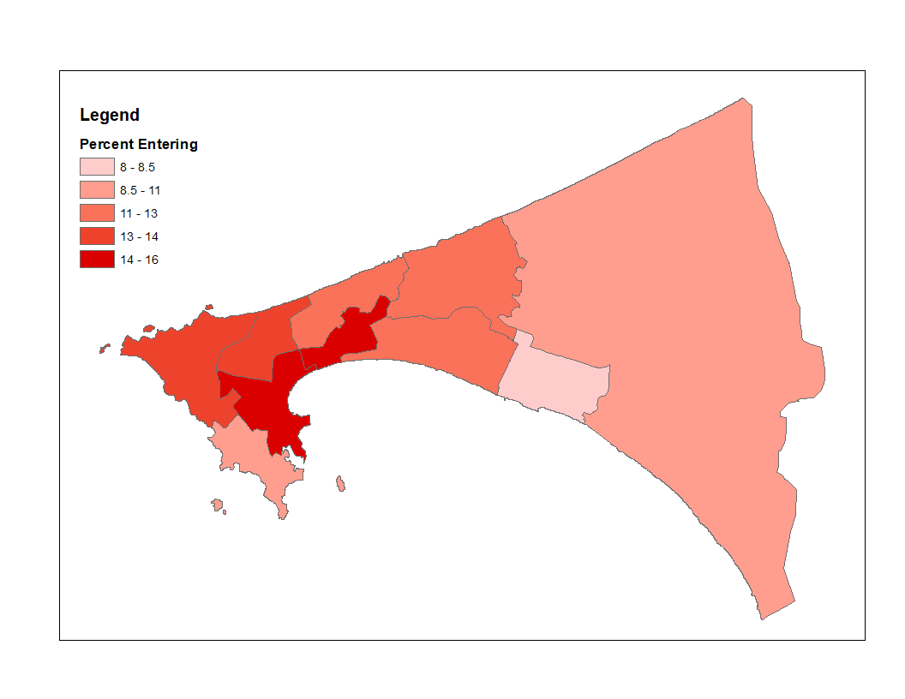

Figure percent of people in November, 2017 that were living somewhere else in july, 2017

In addition to using the mobile phone data to measure long term relocation, we will also use the data to look at commuting and the effects of the BRT and Express Train. For this we can use the more detailed probes data, which provides us with more data points per SIM. We can look at a few different things. For example, for each SIM, we can find the number of different locations visited per day, per week, and per month and study how the number of locations visited changes over time and whether it increases for those living in proximity to the TER and BRT after they are built. We could also look at the distance traveled per day, to see if people are able to travel longer distances. We would calculate this based on all of the probes observations per day for each SIM, calculating distance traveled from one point to the next in chronological order. In collaboration with Josh Blumenstock and Dave Donaldson, Martina Kirchberger is currently developing a new methodology to use mobile phone data in a project that investigates the welfare effects of the Dakar-Diamnadio toll road in Dakar and the E03 expressway connecting central Colombo to Katunayake. We plan to base some of our analysis of the effects of the BRT and the TER on their proposed methodology.

CETUD has already signed a Memorandum of Understanding with Sonatel to receive daily data on the physical origins and destinations of phone owners (based on the location of calls and texts that they make and receive). We will work to expand this MoU to include results from the algorithms that we develop as well.

### 9.2.5 Congestion and Traffic

For congestion and traffic, we will use traffic detecting devices that we will strategically place in different locations in Dakar. These devices will be purchased by CETUD. There are four different types of devices that they plan on using which will provide information on vehicle counts, speed, and classification, and some of which will include cameras that allow observation in real time.

The high frequency data collected by these devices before, during and after construction of the TER/BRT will provide information on how traffic, congestion and speed are affected by the TER and BRT at different stages (for example we may expect congestion to increase during the building phase of the BRT when a major road will be partially blocked for use). They will also provide information on the types of vehicles. This is important because, as mentioned, the TER includes a line for freight; therefore, the trucks that currently carry freight from the harbor may be replaced by the TER within Dakar and loaded outside of the city (since many of them are traveling all the way to Mali and beyond). This could improve efficiency since these trucks would no longer have to travel through the congested city. We may also supplement this data with congestion data available through Google/Waze, but for this we will wait as a partnership between the Bank and Google is currently being developed to allow use of Waze data, but the details of this will not be available until late May.

### 9.2.6 Road Safety Data

Road safety data comes from the Directorate of Road Traffic (DTR), which collects data on all crashes in Senegal, bringing together data from all available sources. We have received some examples of the data they currently have. The aggregated data has information on each accident including the geographic area, the date, the time, the types of vehicles involved and the number of people injured or killed. The appendix includes figures showing some examples of the data. Unfortunately, the aggregated data does not include a location more detailed than the Department. The individual accident data does include more information on location, so we will need to have a data clerk enter this more detailed information. Additionally, DTR is currently working with a consultant to set up a new system of collecting data with GPS location, though this will take some time to implement. Nevertheless, we plan to work with DTR during this process, and we hope that the GPS data will become available during the course of the impact evaluation and can supplement the existing data.

### 9.2.7 Public Transit Data

One of the big advantages of the BRT and TER is that they will have a system of smartcards, which will collect data electronically on where people get on and off. This will allow us to study a number of different indicators including origin and destination of BRT and TER users, total number of individuals getting on and off, use of services, and timing of day and week, among others. A baseline of this type of data has already been created. For all of the lines of the formal transit (the AFTU and DDD), someone rode the busses and recorded the number of people getting on and off at each stop. This type of data is demonstrated in the Appendix. While this type of data only provides a snapshot, as compared to the new smartcard data, which will provide this on an ongoing basis, it still gives us a comparison of ridership along certain lines. All of the stops are geolocated and it is possible for us to attribute how many people are getting on and off at specific locations. We will then be able to compare this to the data after the BRT and TER are functioning. This data also allows us to see how long it takes to get between different stops at different times of day, and we can use this to compare how the length of time required to access different locations will decrease with the new BRT and TER. This is just one piece of data collected at baseline and is part of a large study conducted on the existing public transit system in 2016 to help inform the BRT and to act as a baseline.

### 9.2.8 Preliminary Analysis for Fare Experiment

In designing the fare experiment, we can use existing survey data to determine what types of fares we should be testing. The Household Mobility Survey for Dakar (EMTASUD) conducted in 2015, provides a reliable measurement of mobility practices from the responses of 13,415 people aged 11 and over, representing 3,176 households. First, based on this survey public transport is very widely used in Dakar, with 36% of individuals reporting using it almost every day and another 21% at least once a week. Walking is the primary mode of travel in Dakar, with 70 percent of all trips. The 30 percent motorized trips are served by public transport in 80 percent of cases. Among them, AFTU minibuses ("Tatas") appear to be the most used (35 percent of public transport trips during the week). Next in descending order are cars rapides (20 percent), clandestines (12 percent), regular taxis (10.5 percent), Dakar Dem Dikk buses (6 percent), Ndiaga Ndiaye buses (4 percent), other minibuses and the commuter train, PTB (1 percent of public transport trips each), while 10 percent of public transport trips combine two different public transport modes. We now focus specifically on how the patterns seen in the data reflect how different types of fares may affect different people.

**(a) Differentiated fares benefit those who travel short distances**

EMTASUD data shows that travel times to and from work in Dakar are extremely variable (from 1 minute to 3 hours in a few rare cases). The median travel time in each direction is 20 minutes, so, quite short compared to other developing cities.

The spatial distribution of flows at the departmental level in Dakar overall reveals that most of them take place within a given department (Dakar, Pikine, Guediawaye, or Rufisque). Almost 70 percent of trips by public transport are intra-departmental, meaning that the average distances traveled are relatively short. More than 60 percent of all public transport trips in the Dakar metropolitan area cross into or out of the Dakar department.

According to the Second Poverty Survey for Senegal (Enquête de suivi de la pauvreté au Sénégal, ESPSII, 2011), density of poverty, as expressed in poor individuals per area, is highest in the communes in the Dakar, Pikine, and Guediawaye departments, which tend to be much better served by the existing public transit system compared to the Rufisque department in the city’s eastern part. Individual communes with the highest poverty density are located along the planned BRT and TER lines, in particular, the early sections of the BRT and TER lines in the downtown (Grand Dakar and Biscuiterie communes); the end of the BRT line in Guediawaye in the communes of Medina Gounass and Djidah Thiaroye Kao; and the middle section of the TER route in the communes of Guinaw Raild Nord, Guinaw Rail Sud, Tivaouane Diacksao, and Yeumbeul Sud (Figure 7). Analysis of the work-related origin-destination matrices collected as part of the EMTASUD 2015 survey shows that approximately half of all the trips originating in the highest poverty-density communes for regular work purposes terminate either in the origin commune or in a commune that is less than 3 kilometers away along the proposed BRT or TER routes. The share of such short-distance work commutes exceeds 60 percent for trips originating in Camberene, one of the communes with the highest absolute density of poor households. These patterns suggest that residents of the high poverty-density communes along the proposed BRT and TER routes would be more incentivized to use the new transit systems under a distance-based rather than a flat fare.

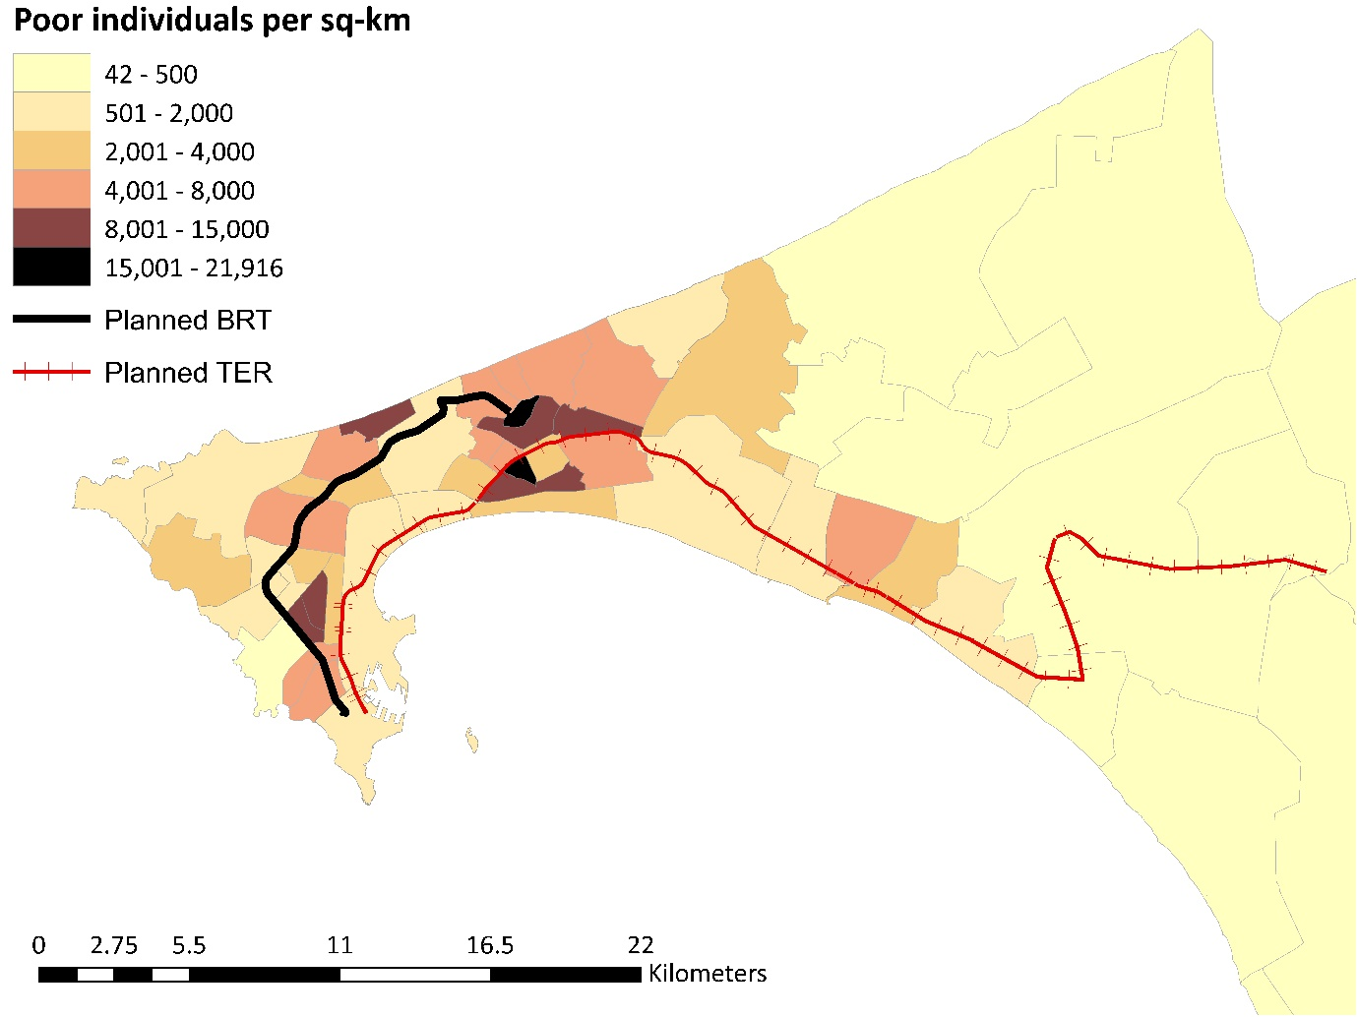

Figure Poverty incidence at the commune level (Source: ESPSII, 2011)

**(b)Distance-based fares may have negative effects on groups living on the urban fringe if they travel long distances to get to work.**

While, as shown in Figure 7, poverty incidence in Dakar is highest in the central communes that coincide with the planned BRT and TER routes, poverty rates are highest on the urban fringe, in the Rufisque department in eastern Dakar that corresponds to the final section of the TER route (Figure 8). In individual communes there the poverty rates exceed 40 percent (in Diamniadio the rate reaches 53 percent).

Calculations based on EMTASUD data show that the density of employment opportunities in this area is very low when compared to the Pikine, Guediawaye and, especially, Dakar, departments (Figure 9). The distribution of jobs currently occupied by individuals with no formal education – which are more likely to be poor – is very similar to the overall job distribution pattern. Therefore, it is possible that the marginalized groups living in the city’s eastern communes would be negatively affected by a distance-based fare, if they have to undertake a long journey to work each day.

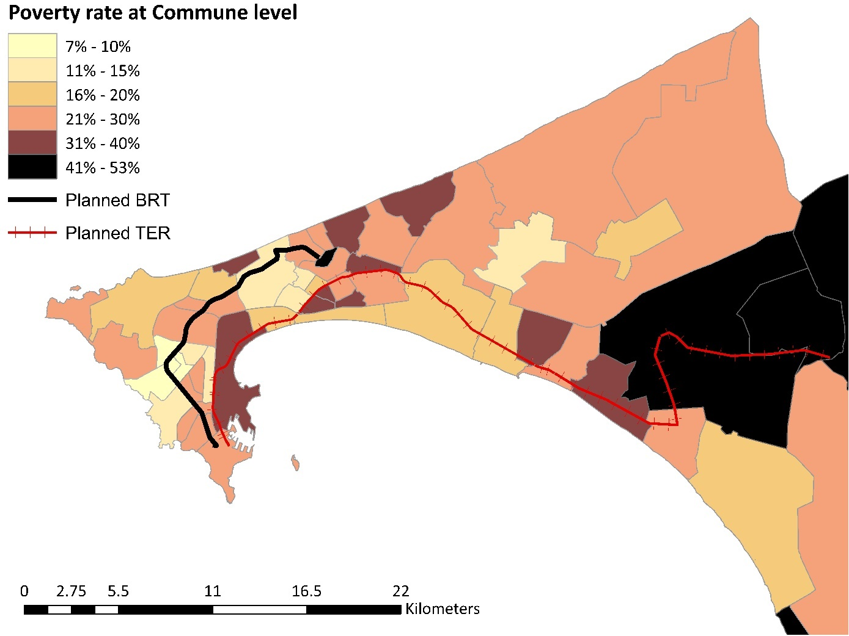

Figure Poverty rate at the commune level (Source: ESPSII, 2011)

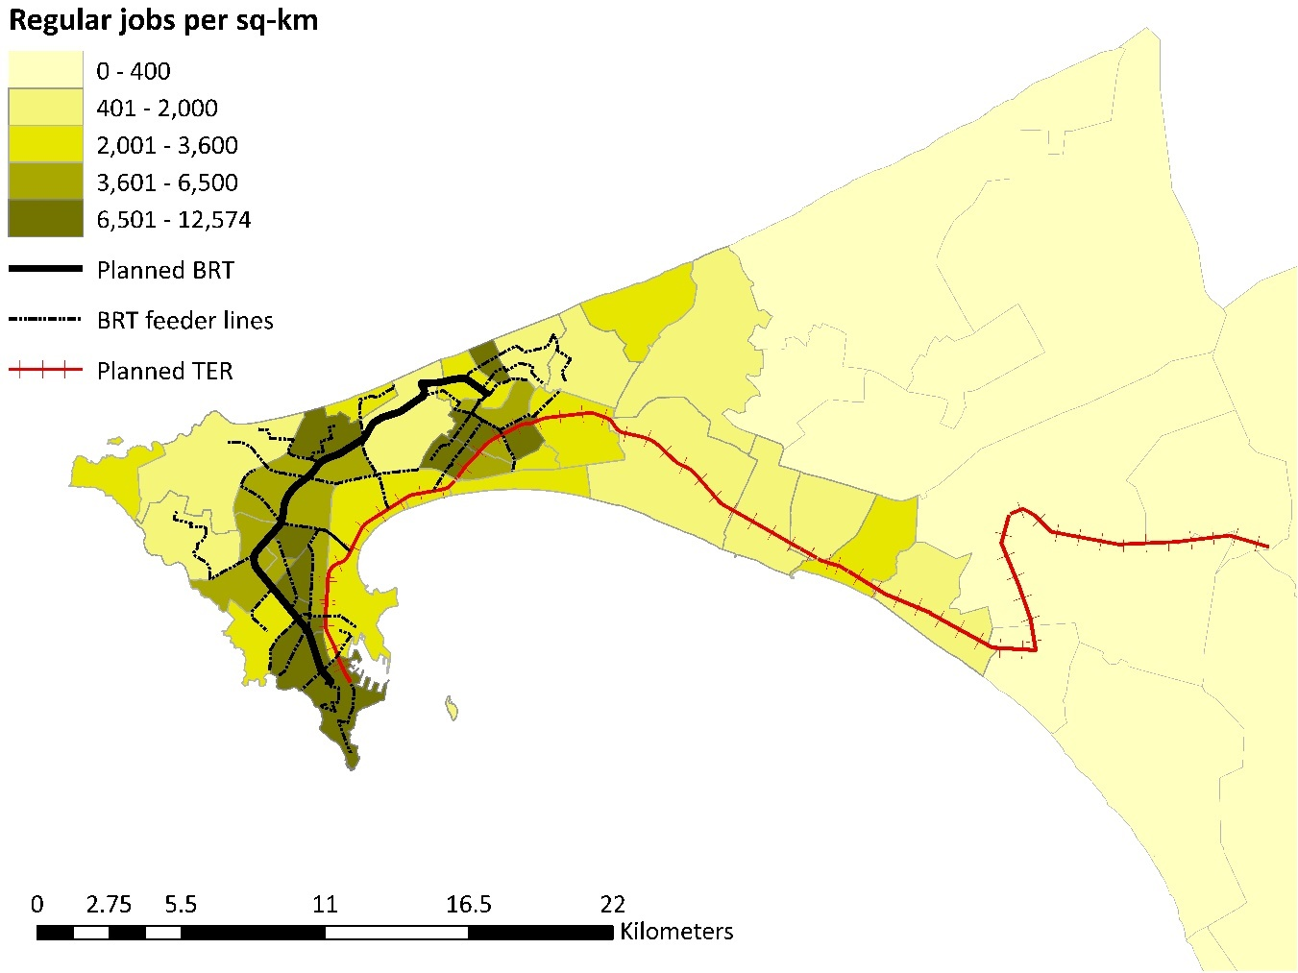

Figure Regular jobs per km2 (Source: inferred from EMTASUD, 2015)

Analysis of the actual current commute patterns, however, shows that in the poorest communes in eastern Dakar – Sebikotane, Diamniadio, and Bargny – the vast majority of individuals work within the boundaries of their home commune. In Diamniadio and Bargny the share exceeds 70 percent and, thus, do not travel more than 5-6 km to get to work. This can be explained by the fact that these communes are not only poor in employment opportunities but also relatively sparsely populated. Given the short commute distances traveled by most commuters in the urban fringe, on average, a differentiated fare for TER services might in fact provide greater benefits for the residents of these communities compared to a flat fare. At the same time, as many as 13 percent of the work trips originating in the three Rufisque communes with the highest poverty rates currently terminate in one of the communes in the Dakar department in the very western part of the city, which means that these commutes would be penalized by a distance-based fare compared to a flat fare, especially if the flat fare is accompanied by free transfers to BRT feeder lines.

**(c)Gender Analysis**

Women, on average, undertake 3.03 trips per day, of which 27 percent are motorized. In contrast, for the population the average number of trips per day during the week is 3.36 per person. Both during the week and on weekends, women travel less than men (20 percent fewer trips). This may be because women are potentially more constrained: slightly more women (6.9% as compared to 6.7 % of men) state that they were not able to conduct an activity in the last 7 days because of travel difficulties. Of these, 40% of women say this was due to a lack of money for the fare, as compared to only 34% of men. 26% of women also said that it was because the location was too far, as compared to only 20% of men, which also signals that women are more likely to try to walk places rather than take transport to get to locations that are far. Men and women also have very different activities that they are unable to perform due to travel difficulties. Looking at the top three activities, 39% of women say the reason for activity was a visit, 12% say it was related to health and 10% say it was for shopping, while for men 23% say it was for a visit, 19% say it was for work and 16% say it was for administrative tasks.

While women did not cite work as an activity they were not able to do due to travel difficulties (as compared to men), part of that reason may be that women are less likely to choose to work if they need to pay for transport to get there or to take a job requiring travel. Based on the data, we calculate that the average daily salary for women is 4351CFA, as compared to 6968CFA for men, which is 60% higher than the average daily wage for women.[6] Comparing the men and women that use public transport and pay to get to work, though, we see that women actually pay more to get to work. On average they pay 654CFA for roundtrip fare to work as compared to 554CFA on average for men. As a percent of wages for these individuals, it accounts for 20% of daily wages for women and only 14% of daily wages for men. This data shows that finding fare pricing that can benefit women could potentially lead to improvements in access to jobs and ability to accept jobs that require travel.

All of this initial analysis shows that studying fare pricing is critical to understand what fares can benefit disadvantages populations the most. It is not necessarily clear what the right fare structure is, and therefore experimenting with this could provide valuable evidence that could lead to increased accessibility and improved labor market outcomes for women and socio-economically disadvantaged individuals.

### 9.2.3 Survey Data Collection

To collect data for a number of indicators, we will conduct household level surveys. These surveys will be used to collect data on labor market (job search as well as jobs conducted); accessibility; public transport ridership; travel frequency and travel time. This data will be asked for all individuals living in the household above age 15. They will also include modules on household demographic information; income, assets and consumption that will be answered by the head of household. These surveys will be conducted at baseline (in 2018), at midline (in early 2020) and at endline (in 2021). We will choose individuals from these households to be part of the fare experiment and in addition to the surveys will also request to access their smartcard data and link this information to the surveys collected.

## Data Coding, Entry, and Editing (E)

For the portion of data collected that will be survey data, initial data coding and entry will be automatically performed after conducting interviews since data will be collected electronically using tablets. The research team will write statistical codes to clean the data, identify discrepancies, duplicates, missing fields, and other data quality controls. The research team will consult with the field team to correct for discrepancies where possible.

## Management of Data Quality

The secondary data we work with will go through an extensive process of checks to test the data for anomalies and outliers and for any issues that will need to be further checked and tested. For household surveys, we will conduct backchecks and data will be collected using electronic survey tools. Digitally collected data minimizes data capture errors, restricts the range of possible answers, and automatically queries infeasible answers. The field coordinator will periodically audit fieldwork activities and data will be checked by a research assistant after it has been uploaded.

## Ethical Issues

Given the variety of data that we are using for this project, different types of ethical issues will need to be addressed.

For a number of secondary data that we will use, ethical issues do not arise. This applies to the air quality index data measured by stationary and mobile devices, satellite imagery used to analyze changes in buildings, traffic data collected through radar devices, and public transit data on number of people getting on and off busses/travel routes/travel times of buses collected through electronic devices on buses. In all of these cases there are no human subjects and therefore ethical approval is not necessary (for the public transit data, it is information at the bus level, and will not include any information on specific individuals).

For the data on housing prices from DGID and real estate agencies, we will request that data is anonymized so that there is no identifiable personal information on any individuals living at the property, including names. Instead, we will only request building specific information including the location of the building and price at which the building was bought/sold, and any building amenity information. Similarly, for the road safety data, we will request that any identifiable information such as names and driver’s licenses are removed, and only information concerning the accident (location, vehicles and number of people involved, severity) remain. For smartcard data, we will only work with anonymous data that does not contain information on the individuals and will aggregate data to study mobility patterns generally. For the mobile phone data, we will again request that any data we work with is anonymized and there is no personally identifiable information such as name or phone number. In addition, for the mobile phone data, once we have developed adequate algorithms, we can have algorithms run directly at Sonatel and only the aggregated data produced by the algorithm will be released to the data system and the researchers. In this way, after the initial algorithms are developed, researchers will no longer interact with the raw data directly. For all of these types of data, we will request an IRB exemption, given that there will be no personally identifiable information.

For any household and individual surveys that we conduct, we will submit for IRB approval. All questionnaires will be vetted through IRB, and informed consent will be asked for all participants. Respondents have the option to decide not to participate in the entire survey or to skip certain questions or sections of the surveys without repercussions. For the fare experiment where we will want to track smartcards for the specific individuals that are part of the experiment, we will request explicit permission to access their smartcard data and link it to the survey data that we collect.

## IE Implementation Monitoring System (R)

The project will be monitored by both the World Bank team in Washington DC as well as an in-country field coordinator that will oversee all activities including implementation of randomization and follow up of treatment and control participants for the fare experiment. Additionally, the data system that will be put in place that will collect on-going data for some variables will be monitored throughout the IE process.

# Study Limitations and Risks (E)

The most significant risk to this IE is the Authorities’ failure to commission these two new transport systems. While a possibility, this risk doesn’t seem very likely. The TER construction has already begun along the Dakar city center – Diamniadio section. The BRT planning phase is well advanced and construction expected to begin in January 2019.

The main risk to internal validity is the difficulty of finding a proper control group, given that Dakar’s geography leaves us with few areas that will not be affected by the BRT or TER (parallel trend and spillover-related econometric issues). The evaluation design section discusses alternative methods to address these issues. To tackle this further, when doing analysis on the secondary data, instead of having a dummy variable for treatment and control, we may want to work with a continuous treatment variable based on distance and allow for a flexible functional form since the effects may not be linear. We will also run a battery of sensitivity tests, including placebo experiments and balance on observables pre-treatment.

There are also risks stemming from data quality and measurement error issues. There is risk with the road safety data that DTR will not set up the system of geolocated data collection within the timeframe of the study, and the data will not be granular enough for us to measure the effects of the BRT and TER. Given that road safety is a key component of consideration for the BRT with dedicated funding, we can work with the project team to implement the necessary data collection outside of DTR using part of the allocated project funding.

For the fare experiment, one of the big risks is that it is possible that users that receive subsidized fares may lend their fare card to others to use (for example, a family member). We may need to therefore potentially provide the subsidies to all adult members of the family, or else have a way of checking travel (for example through some type of GPS device that participants consent to wear). We can also conduct focus groups at the different stages of the fare experiment to learn more about the process and how the cards are used (for example, meeting with participants after the end of the TER pilot in order to learn more that we can apply to the experiment on the BRT). Attrition is another potential risk. The baseline survey data collection will ensure that as much contact information from the study participants is collected (including mobile phone numbers). Hawthorne effects (the alteration of behavior by the subjects of a study due to their awareness of being observed) are expected to be minimal and should be balanced across the treatment and control arms, if any.

In terms of external validity, this IE is very representative of Dakar, since a majority of the secondary data will actually be datasets covering the whole city. For the survey data, we will make sure to randomly select individuals in a way that will ensure representativeness. Additionally, as an urban hub, Dakar is representative of other large metropolitan capitals and major cities in other countries in Africa, and can provide insights as others consider investing in new public transit infrastructure such as BRT systems. As a peninsula, the geography of Dakar is unique, and leads to additional challenges of congestion that not all cities may face, yet, many cities in Africa are experiencing similar problems with traffic, pollution, road safety and accessibility.

# IE Management (E,R)

## Evaluation Team and Main Counterparts

**Table 2. IE Team and Main Counterparts**

|  |  |  |
| --- | --- | --- |
| Name | Role | Organization/Unit |
| Pascal Jaupart | Researcher | University of Oxford |
| Martina Kirchberger | Researcher | Trinity College Dublin |
| Carol Newman | Researcher | Trinity College Dublin |
| Sveta Milusheva | ieTTL/ Researcher | World Bank/DIME |
| Amadou Boly | Researcher | Islamic Development Bank |
| Aiga Stokenberga | Researcher | World Bank/GTD |
| Franck Taillandier | WBG Project TTL | World Bank/GTD |
| Ndeye Anna Ba | WBG Project staff involved in the IE | World Bank/GTD |
| Tojo Ramanankirahina | WBG Project staff involved in the IE | World Bank/GTD |
| Mouchili Mayoua | IsDB Project TTL | Islamic Development Bank |
| Baye Elimane Gueye | Main implementing and policy counterparts | CETUD |
| Gora Sarr | Main implementing and policy counterparts | CETUD |
| Pape Monar Lo | Main implementing and policy counterparts | APIX |
| Adama Wade | Main implementing and policy counterparts | APIX |

## Work Plan and Deliverables

**Table 3. Milestones, Deliverables, and Estimated Timeline**

|  |  |  |
| --- | --- | --- |
| Milestones | Deliverables | Completion Date |
| Peer-reviewed Concept Note | [Methodology note](https://www.wbginvestmentclimate.org/results/upload/Method_Note_Kenya_HI_06Nov2013_ext.pdf) | April 15, 2018 |
| Data collection plan | TORs  Questionnaires | June, 2018 |
| Data collection (Baseline) | Cleaned data  Dictionaries | December, 2018 |
| First data analysis | Presentation  Data file  Do files  Baseline report | March, 2019 |
| Implementation of TER fare experiment | Rollout plan  Monitoring reports verifying treatment and control status | June, 2019 |
| Data collection for TER fare experiment (Follow-up) | Cleaned data  Dictionaries | December, 2019 |
| Midline data collection for various indicators in data system (some will have been collected continuously throughout) | Cleaned data  Dictionaries | December, 2020 |
| Implementation of BRT fare experiment | Rollout plan  Monitoring reports verifying treatment and control status | June, 2021 |
| Data collection for BRT fare experiment (Follow-up) | Cleaned data  Dictionaries | December, 2021 |
| Endline data collection for various indicators in data system (some will have been collected continuously throughout) | Cleaned data  Dictionaries | December, 2021 |
| Final report and policy notes | Technical note  Policy note  Data file  Do files | January, 2022 |
| Dissemination of findings | Presentations | March, 2022 |

## Budget

Tables 4 and 5 present the total budget for the project as well as the requested budget from the ieConnect program (Detailed budget is attached). Seed funding in the amount of $25,000 from the ieConnect program is gratefully acknowledged. Baseline data will be collected through project funding dedicated for this in the amount of $300,000. The Islamic Development Bank and African Development Bank may be able to contribute additional funds for this project upon acceptance of the Concept Note.

**Table 4. Total Budget per Category**

|  |  |  |
| --- | --- | --- |
| Category | USD | % |
| Staff | $66,119 | 6% |
| STC | $303,745 | 27% |
| Data Collection | $597,044 | 54% |
| Travel | $139,210 | 13% |
| Total | $1,106,118 | 100% |

**Table 5. Budget Requested per Category**

|  |  |  |
| --- | --- | --- |
| Category | USD | % |
| Staff | 0 | 0% |
| STC | $75,000 | 50% |
| Data Collection | $50,000 | 33% |
| Travel | $25,000 | 15% |
| Total | $1,106,118 | 100% |

# Plan for Using Data and Evidence from the Study

Throughout the study, we will be constantly updating the government organizations we work with and MDB project teams on the progress and results at different stages. These will include baseline reports, summary statistics from data collection, preliminary analyses and interpretations. Given the data system we set up will be collecting data on an on-going basis, we will use this to produce useful analysis at different points in time based on the data collected. We will produce briefs on different topics covered by the data, including air quality and congestion, gentrification and housing prices, and mobility more generally. We will also produce blogs throughout that reflect the progress of the project as well as demonstrate how the data system can be used in different ways.

Once the study is completed, our findings will be disseminated through policy briefs and presentations, locally and in policy and academic conferences. We are planning an inter-ministerial conference in Dakar to further discuss the impact of large infrastructure projects with policymakers. We will produce short and easy to digest policy briefs at each stage of the project that will summarize the key takeaways and lessons learned, and we plan to distribute these to a wide policy audience in order to provide policy makers with valuable evidence. For some areas, such as with the mobile phone data analysis, we will also produce technical papers that describe innovative new methods of analysis and focus on methodological questions. Given the large scope of the data, we also plan to produce several academic papers. Since we have a large team that contributes different expertise, we will be able to produce material for various audiences covering the different questions and outcomes that we will analyze.

# References

Abratedargay, G., M. Piacenza, D. Vannoni. (2009). The impact of Integrated Tariff Systems on public transport demand: Evidence from Italy. Regional Science and Urban Economics, 39, pp. 120–127.

Al-Kazily, J., C. Barnes, and N. Coontz. (1994). Household Structure and Travel Behavior. NPTS Demographic Special Reports. FHWA.

Ballou, D.P., Mohan, L. (1981). A decision model for evaluating transit pricing policies. Transp. Res. A: Gen. 15 (2), pp. 125–138.

Bandegani, M. and M. Akbarzadeh. (2016). Evaluation of Horizontal Equity under a Distance-Based Transit Fare Structure. Journal of Public Transportation, 19(3), pp.161-172.

Banerjee, Abhijit and Sandra Sequeira. 2014. "Transport Subsidies and Job Matchmaking In South Africa." AEA RCT Registry. June 19. https://www.socialscienceregistry.org/trials/362/history/1922

Bel, G., & Holst, M. (2018). Evaluation of the impact of Bus Rapid Transit on air pollution in Mexico City. *Transport Policy*, *63*, 209-220.

Bjorkegren, Daniel. (2015). "The adoption of network goods: evidence from the spread of mobile phones in Rwanda." Accepted, Review of Economic Studies.

Blumenstock, Joshua, Gabriel Cadamuro, and Robert On. "Predicting poverty and wealth from mobile phone metadata." Science 350.6264 (2015): 1073-1076.

Bocarejo, S.J.P., Oviedo, H.D.R. (2012). Transport accessibility and social inequities: a tool for identification of mobility needs and evaluation of transport investments. J. Transp. Geogr. 24, pp. 142–154.

Bocarejo, J. P., Portilla, I., & Pérez, M. A. (2013). Impact of Transmilenio on density, land use, and land value in Bogotá. *Research in Transportation Economics*, *40*(1), 78-86.

Bocarejo, J. P., Portilla, I., & Meléndez, D. (2016). Social fragmentation as a consequence of implementing a Bus Rapid Transit system in the city of Bogotá. *Urban Studies*, *53*(8), 1617-1634.

Borndooerfer R, Karbstein M, Pfetsch ME. (2012). Models for fare planning in public transport. Discrete Applied Mathematics, 160(18), pp. 2591-2605.

Boschmann, E.E., Kwan, M.P. (2008). Toward socially sustainable urban transportation: progress and potential. Int. J. Sustain. Transp. 2 (3), pp. 138–157.

Bueno Cadena, P. C., J. M. Vassallo, I. Herraiz, and M. Loro. (2016). Social and Distributional Effects of Public Transport Fares and Subsidy Policies Case of Madrid, Spain. Transportation Research Record: Journal of the Transportation Research Board, No. 2544, Transportation Research Board, Washington, D.C., pp. 47–54.

Cervero, R. (1981). Flat versus differentiated transit pricing: What’s a fair fare? Transportation, 10, pp. 211–232.

Cervero, R. and M. Wachs. (1982). An Answer to the Transit Crisis: The Case for Distance-Based Fares. Journal of Contemporary Studies, 5(2), pp. 59-70.

Cervero, R., & Kang, C. D. (2011). Bus rapid transit impacts on land uses and land values in Seoul, Korea. *Transport Policy*, *18*(1), 102-116.

Cheng, S., Q. Gao, and Y. Zhang. (2016). Evaluating the Impacts of Bus Fare on Social Equity Based on IC Card Data in China. Sustainability, 8 (1032), pp. 1-15.

Chien I.J., Tsai C.F.M. (2007). Optimization of Fare Structure and Service Frequency for Maximum Profitability of Transit Systems. Transportation Planning and Technology, 30(5), pp. 477-500.

Dargay, J.M., Pekkarinen, S. (1997). Public transport pricing policy: empirical evidence of regional bus card systems in Finland. Transportation Research Record 1604, pp. 146–152.

De Rus, G. (1990). Public transport demand elasticities in Spain. Journal of Transport Economics and Policy 24, pp. 189–201.

Deakin, E., Harvey, G. (1996). Transportation pricing strategies for California: an assessment of congestion, emissions, energy and equity impacts, final report. California Air Resources Board, Sacramento, CA.

Farber, S., K. Bartholomew, X. Li, A. Páez, K. M. Nurul Habib. (2014). Assessing social equity in distance based transit fares using a model of travel behavior. Transportation Research Part A, 67, pp. 291–303.

Franklin, S. (2015). Location, search costs and youth unemployment: A randomized trial of transport subsidies in Ethiopia. Centre for the Study of African Economies Working Paper WPS/2015-11.

Glaeser, E. L., Kahn, M. E., and J. Rappaport. (2008). Why do the poor live in cities? The role of public transportation. Journal of Urban Economics, 63(1), pp. 1-24.

Gordon P., A. Kumar, and H. W. Richardson. (1989). Gender Differences in Metropolitan Travel Behaviour. Regional Studies, 23, pp. 499–510.

GSMA 2018. Air Quality Monitoring Using IoT and Big Data: A Value Generation Guide for Mobile Operators. February 2018. <https://www.gsma.com/iot/wp-content/uploads/2018/02/iot_clean_air_02_18.pdf>

Handy, S. (2006). Community Design and Travel Behavior: Exploring the Implications for Women. In Conference Proceedings 35: Research on Women’s Issues in Transportation: Report of a Conference; Volume 1: Conference Overview and Plenary Papers, Transportation Research Board of the National Academies, Washington, D.C., pp. 29–38.

Hanson, S., and I. Johnston. (1985). Gender Differences in Work-Trip Length: Explanations and Implications. Urban Geography, 6, pp. 193–219.

Hildalgo, D. and Graftieaux, P. 2008. Bus rapid transit systems in Latin America and Asia: results and difficulties in 11 cities. Transportation Research Record, Vol. 2072, pp. 77A88.

Hildalgo, D., Pereira, L., Estupiñán, N., and Jiménez, P. 2013. TransMilenio BRT system in Bogotá: highAperformance and positive impacts; main results of an exApost evaluation.   
Research in Transportation Economics, Vol. 39, No. 1, pp. 133A138.

Hildalgo, D. and Yepes, T. 2005. Are bus rapid transit systems effective in poverty reduction? Economist Intelligent Unit. 2010. Liveanomics: urban liveability and economic growth.   
[http://www.managementthinking.eiu.com/liveanomics.html. Accessed June 25, 2013](http://www.managementthinking.eiu.com/liveanomics.html.%22%22%22%22Accessed%22June%2225,%222013).

Isaacman, S., Becker, R., Cáceres, R., Kobourov, S., Martonosi, M., Rowland, J. and Varshavsky, A. (2011). Identifying important places in people’s lives from cellular network data. In International Conference on Pervasive Computing (pp. 133-151). Springer, Berlin, Heidelberg.

Johnson, F. and A. Ford. (2013). Public Transport Fare Structure Review: Exploration of Options. Greater Wellington Regional Council, Wellington, New Zealand.

Kamuhanda, R., and O. Schmidt. (2009). Matatu: A Case Study of the Core Segment of the Public Transport Market of Kampala, Uganda. Transport Reviews, 29(1), pp. 129–142.

Kuhnimhof, T., Chlond, B., von der Ruhren, S. (2006). Users of transport modes and multimodal travel behavior. Transp. Res. Rec., pp. 40–48.

Ling, J.H. (1998). Transit fare differentials: A theoretical analysis. Journal of Advanced Transportation, 32(3), pp. 297-314.

Liu, B.-Z., Y.-E. Ge, K. Cao, X. Jiang, L. Meng, D. Liu, and Y. Gao. (2017). Optimizing a desirable fare structure for a bus-subway corridor. PLoS ONE 12(10), pp. 1-21.

Luhrsen, K.F. and B.D. Taylor. (1997). The High Cost of Flat Fares: An examination of ridership demographics and fare policy at the Los Angeles MTA. Working Paper, UCLA Institute of Transportation Studies.

Mayworm, P. D., Lago, A. M., and McEnroe, J. M. (1980). Patronage Impacts of Changes in Transit Fares and Services. Urban Mass Transportation Administration, Ecosometrics, Incorporated, Bethesda, MD.

McGuckin, N., and N. Srinivasan. (2003). Journey to Work: Trends in the United States and Its Major Metropolitan Areas. FHWA-EP-03-058. FHWA, U.S. Department of Transportation.

Michelson, W. (1983). The Impact of Changing Women’s Roles on Transportation Needs and Usage. Report DOT-I-83-01. U.S. Department of Transportation, Washington, D.C.

Miller, C. and I. Savage. (2017). Does the demand response to transit fare increases vary by income? Transport Policy, 55, pp. 79–86.

Moser, C. (1993). Gender Planning and Development: Theory, Practice and Training. Routledge, London.

Nijkamp, P., Pepping, G. (1998). Meta-analysis for explaining the variance in public transport demand elasticities in Europe. Journal of Transportation and Statistics 1, pp. 1–14.

Nobis, C., and B. Lenz. (2006). Gender Differences in Travel Patterns: Role of Employment Status and Household Structure. In Conference Proceedings 35: Research on Women’s Issues in Transportation: Report of a Conference; Volume 2: Technical Papers, Transportation Research Board of the National Academies, Washington, D.C., pp. 114–123.

Nuworsoo, C., A. Golub, E. Deakin. (2009). Analyzing equity impacts of transit fare changes: Case study of Alameda–Contra Costa Transit, California. Evaluation and Program Planning, 32, pp. 360–368.

Odufuwa, B. O. (2005). Liberating Women from the Stranglehold of Poverty: A Case of Selected Rural Women in Ogun State. International Journal of Violence and Related Studies, pp. 559–570.

Paulley, N., Balcombe, R., Mackett, R., Titheridge, H., Preston, J., Wardman, M., Shires, J., White, P., 2006. The demand for public transport: the effects of fares, quality of service, income and car ownership. Transport Policy 13 (4), pp. 295–306.

Pfutze, Tobias and Rodriguez Castelan, Carlos and Valderrama Gonzalez, Daniel (February 15, 2018), Urban Transport Infrastructure and Household Welfare: Evidence from Colombia. World Bank Policy Research Working Paper No. 8341. Available at SSRN: <https://ssrn.com/abstract=3124703>

Pisarski, A. (2006). Commuting in America III. Transportation Research Board of the National Academies, Washington, D.C.

Pratt, R. et al. (2000). Traveler Response to Transportation System Changes. Transit Cooperative Research Program, Transportation Research Board. Washington, D.C..

Pratt, R. H., Pedersen, N. J., and Mather, J. J. (1977). Traveler Response to Transportation System Changes—A Handbook for Transportation Planners [first edition]. Federal Highway Administration, U.S. Department of Transportation, Washington, DC.

Pucher, J., and J. Renne. (2003). Socioeconomics of Urban Travel. Transportation Quarterly, 57(3), pp. 49-77.

Rodríguez, D. A. and Targa, F. (2004) Value of accessibility to Bogota’s bus rapid transit system,*Transport Reviews,* 24(5), 587–610.

Rosenbloom, S. (2005). Understanding Women’s and Men’s Travel Patterns: The Research Challenge. In Conference Proceedings 35: Research on Women’s Issues in Transportation: Report of a Conference; Volume 1: Conference Overview and Plenary Papers, Transportation Research Board of the National Academies, Washington, D.C., pp. 7–28.

Rosenbloom, S. (2000). Trends in Women’s Travel Patterns. In Women’s Travel Issues: Proceedings from the Second National Conference, October 1996, FHWA, U.S. Department of Transportation, Washington, D.C., pp. 16–34.

Rosenbloom, S. (1989). Trip-Chain Behaviour: A Comparative and Cross-Cultural Analysis of the Travel Patterns of Working Mothers. In Gender, Transport and Employment (M. Grieco, L. Pickup, and R. Whipp, eds.), Gower Publishing Company, Aldershot, United Kingdom.

Rosenbloom, S. (1987). The Impact of Growing Children on Their Parents’ Travel Behavior: A Comparative Analysis. In Transportation Research Record 1135, TRB, National Research Council, Washington, D.C., pp. 17–25.

Sharaby, N., and Y. Shiftan. (2012). The impact of fare integration on travel behavior and transit ridership. Transport Policy 21, pp. 63-70.

Sirikijpanichkul, A., and S. Winyoopadit. (2013). “Price Elasticity of Demand and Transit Fare Strategy: A Case Study of Bangkok Mass Transit System.” Proceedings of the 4th International Conference on Engineering, Project, and Production Management (EPPM 2013), pp. 346-360.

Skinner, L., and K. Borlaug. (1980). Shopping Trips: Who Makes Them and When. In Women’s Travel Issues: Research Needs and Priorities (S. Rosenbloom, ed.), U.S. Department of Transportation, Washington, D.C., pp. 105–126.

Srinivasan, S. (2005). Influence of Residential Location on Travel Behavior of Women in Chennai, India. In Conference Proceedings 35: Research on Women’s Issues in Transportation: Report of a Conference; Volume 2: Technical Papers, Transportation Research Board of the National Academies, Washington, D.C., pp. 4–13.

Strathman, J., and K. Dueker. (1994). Understanding Trip Chaining. NPTS Demographic Special Reports. FHWA, Washington, D.C.

Streeting, M., and P.P. Charles. (2006). Developments in transit fare policy reform. 29th Australasian Transport Research Forum, pp. 1-13.

Studenmund, A.H., Connor, D. (1982). The free-fare transit experiments. Transportation Research Part A: General. Vol. 16, Issue 4, pp. 261-269.

Transportation Research Board. (2011). Women’s Issues in Transportation. Summary of the 4th International Conference, Vol. 2: Technical Papers, Irvine, CA, October 27-30, 2009.

Transportation Research Board (TRB). (2004). Transit Pricing and Fares: Traveler Response to Transportation System Changes. TCRP Report 95, Transit Cooperative Research Program.

Verbich, D. and A. El-Geneidy. (2016). Are the transit fares fair? Public transit fare structures and social vulnerability in Montreal, Canada. Transportation Research Part A: Policy and Practice, 96, pp. 43-53.

Wardman, M., and S. Grant-Muller. (2011). “Price Elasticities of Travel Demand in Great Britain: A Meta-Analysis.” In Transportation Research Board 90th Annual Meeting (No. 11-3544).

Yazici, M., Levinson, H., Ilicali, M., Camkesen, N., Kamga, C. 2013. A bus rapid transit line case study: Istanbul’s Metrobus system. Journal of Public Transportation, Vol. 16, No. 1, pp. 153A177.

Zagatti, G. A., Gonzalez, M., Avner, P., Lozano-Gracia, N., Brooks, C. J., Albert, M., ... & Tatem, A. J. (2018). A trip to work: Estimation of origin and destination of commuting patterns in the main metropolitan regions of Haiti using CDR. Development Engineering.

Zhang, J., X. Yan, M. An, and L. Sun. (2017). The Impact of Beijing Subway’s New Fare Policy on Riders’ Attitude, Travel Pattern and Demand. Sustainability, 9 (689), pp. 1-21.

# Appendix

### Air Quality

Figures A1 and A2 show the trends in air quality for the six years of data that we have available. We see that there are very clear seasonal patterns. In Figure A2B, we remove the seasonality by regressing the values on month and year fixed effects and graphing the residuals. We see that there are nevertheless large fluctuations that are not related to seasonal patterns. These long trends in air quality data will allow us to better understand the impact of the BRT and the TER on air quality, both during and after construction.

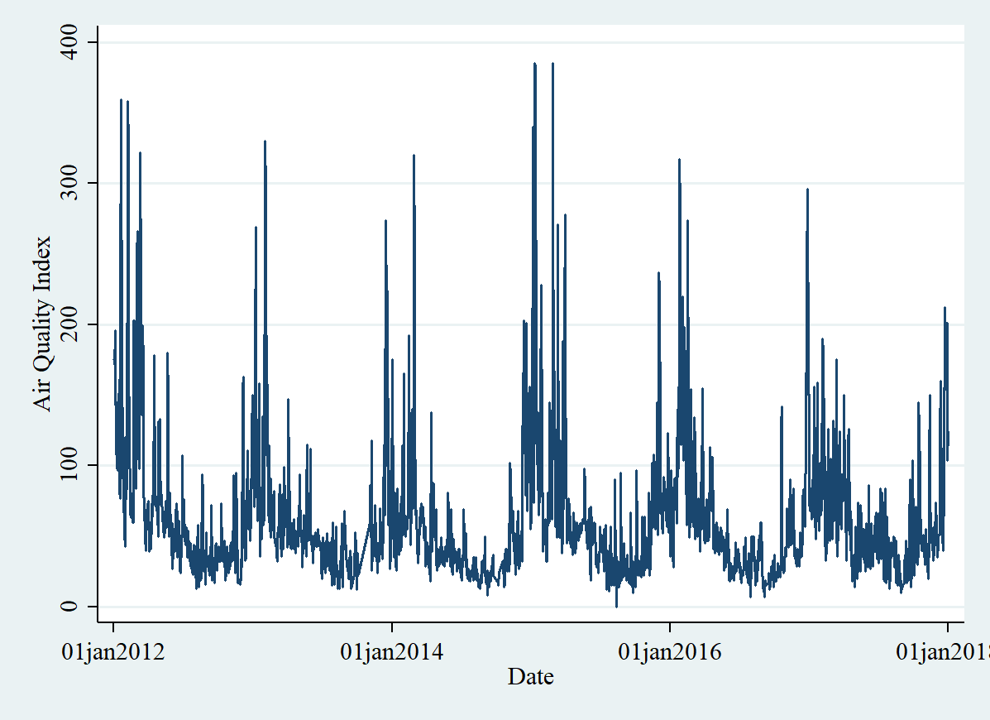

Figure A1 Daily AIR QUALITY INDEX

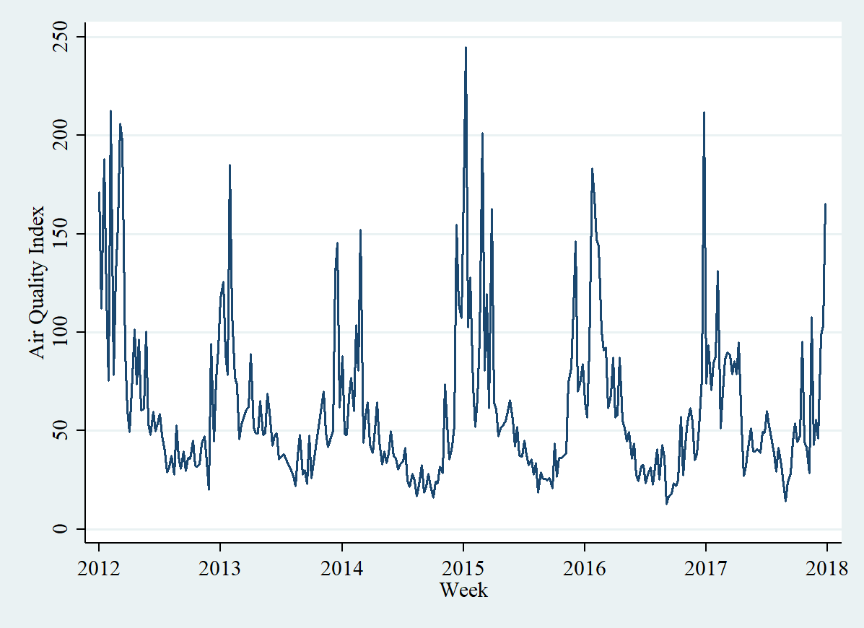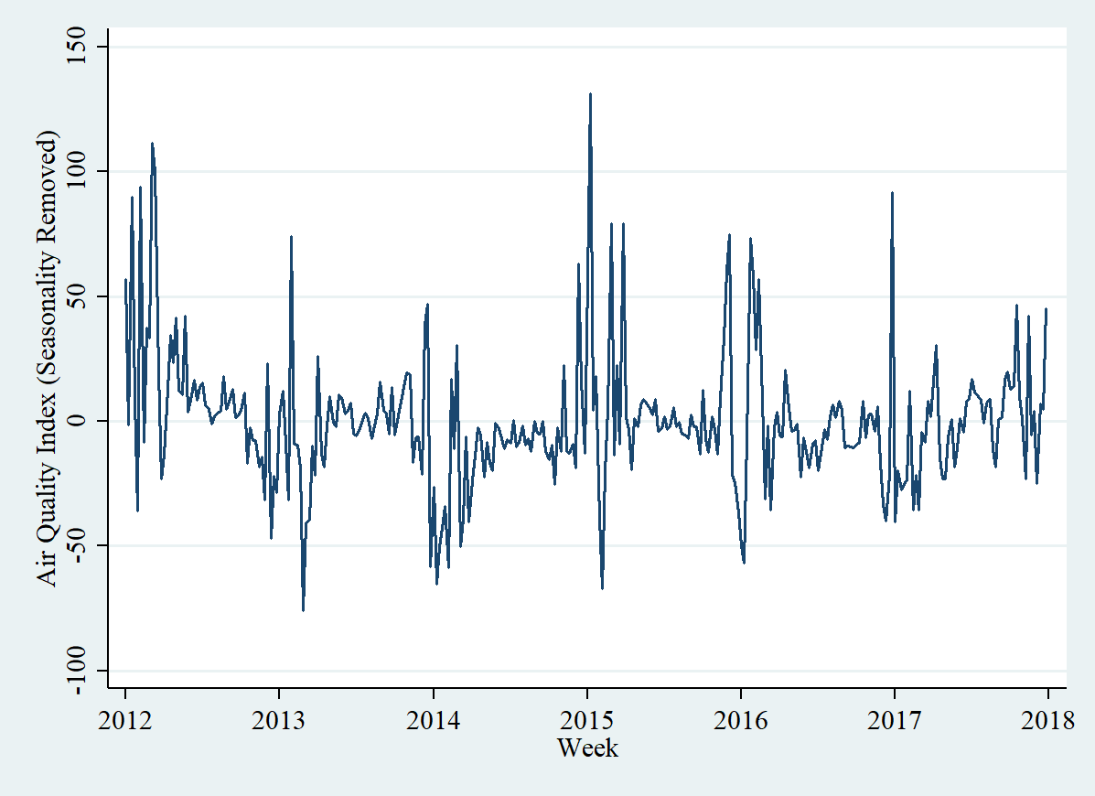

Figure a2b wEEKLY AIR QUALITY INDEX WITH SEASONALITY REMOVED

Figure A2A wEEKLY AIR QUALITY INDEX

### Road Safety

As described in the main text, we currently have data from the DTR on road traffic accidents. For example, Figure A3A below shows an analysis of the data from Central Dakar for the month of May. Figure A3B looks specifically at accidents along the new highway in Dakar. We will work with DTR to obtain all of this available data as far back as it goes for the different areas of Greater Dakar.



Figure A3A aCCIDENTS IN dakar in may 2017

Figure A3B Accidents along the autoroute in dakar in 2016

### Public Transit Data

As described in the text, there was also extensive data collected on the transit system in 2016 during the process of planning for the BRT. We show one example of this type of data in Figure A4, below. In this Figure, we look at one bus line and the number of different people getting on at each stop recorded at four different points in time on the same day. It shows how ridership varies throughout the day. It can be used to help us understand mobility across the city via the formal buses, and we can even use some of the data collected as a measure for the length of time it takes to get between different points on the existing formal public transit system. For the BRT and the TER, we will have much more detailed data on ridership from the smartcards, but there is already some electronic data collected on the AFTU busses that can provide comparable baseline estimates.



Figure A4 Number of people getting on a specific bus at each stop at different points in time

### Measuring Mobility

As described in the text, we will work with mobile phone data to measure mobility and gentrification. We have worked to create an algorithm based on previous literature that takes the CDR data and for each SIM card, clusters the data, and then identifies clusters as Home or Work locations. Figure 5A shows an example for a few SIMs of how different locations where the same SIM makes/receives calls/texts are clustered together spatially. Once geospatial clustering has been done, we then analyze all calls and texts within a cluster to define a cluster as either a home or a work location. This is done in a way similar to Zaggati et al (2018). We label any calls/texts during work hours on weekdays as 1, any calls/texts on weekends, or during off-work hours, as -1 (with one hour buffers between work and non-work hours that are labeled as 0). We then sum across all calls/texts for the cluster for the SIM, and assign any clusters with a negative value as a Home cluster.

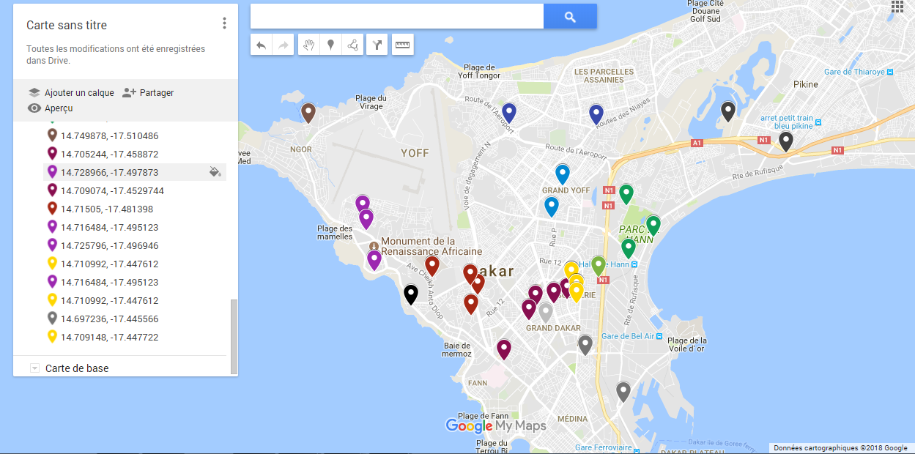

Figure A5 clustering of phone calls by sim

Right now the algorithm is rudimentary and several issues have arisen that we will need to spend time working through. First, the current assignment of Home will sometimes lead to many different clusters being assigned as a Home location for some, and no cluster for others. We will work to refine the home definition, and conduct sensitivity checks. Additionally, if we want to analyze movement and gentrification at a finer spatial level, we run into the issue that if location shifts slightly from one month of analysis to another because the proportion of calls the person makes in a given month from different places changes, it could actually look like a person is relocating. This is demonstrated in Figure A6 below, where we have conducted the same analysis as in Figure 6 in the text, but rather than looking at the arrondissement level, we now look at the much more detailed neighborhood level. We see that it looks like a much higher percentage of individuals had a different home location in July as compared to November. More likely, though, is that we are capturing slight shifts in the definition of the home location. As we develop the algorithm further and refine it, we can aim to account for this. Currently, the centroid of the Home cluster is assigned a neighborhood, and then we compare if neighborhoods change between July and November. Instead, we could directly compare the centroids of clusters and determine if the distance between the Home centroid in July and the Home centroid in November is large enough that we would define it as a relocation. We can then work with different radii to determine whether two centroids are close enough to be considered the same home. Additionally, since we will be comparing changes over time between areas close to and far from the BRT/TER, these extra relocations that we are calculating because they may live close to the border of two neighborhoods will cancel out over time and when comparing the difference in differences across areas. Therefore, while this data has limitations, it nevertheless provides a very useful source for measuring relocation over time at very high spatial and temporal frequencies.

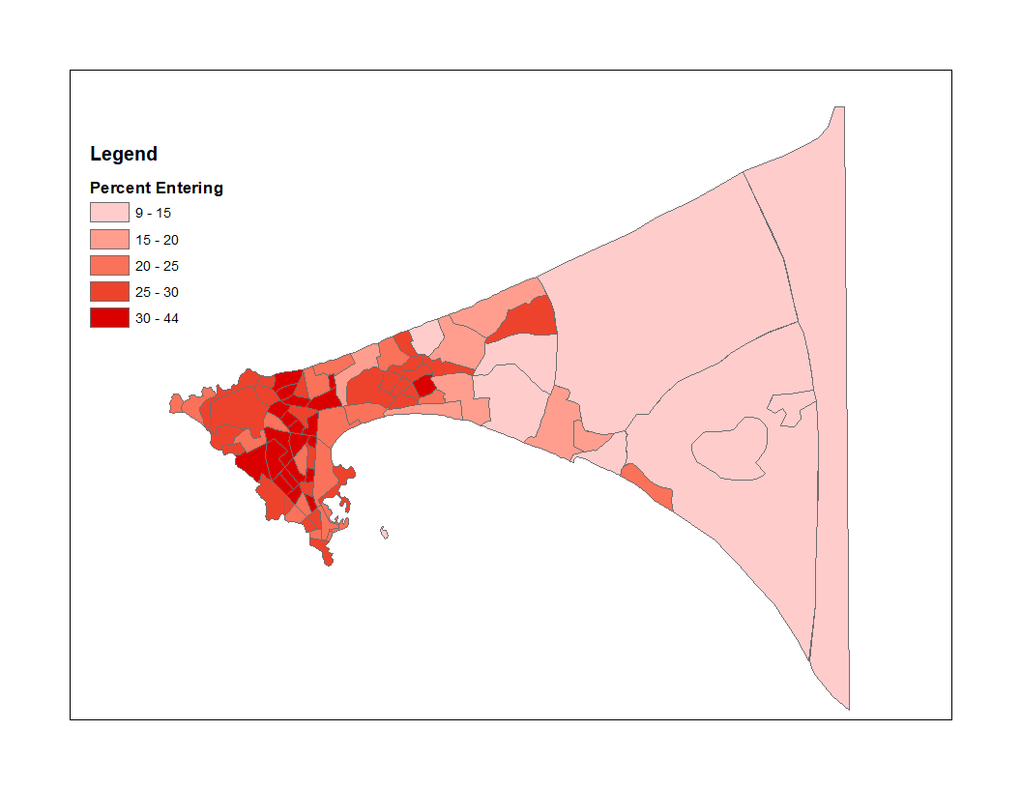

Figure A6 Percent of people relocating at neighborhood level

1. Please refer to JEL classification codes <http://papers.ssrn.com/sol3/displayjel.cfm> .
2. The concept note is aligned to Ethical clearance (E) and Registry (R) indicative requirements. These indicative requirements are referenced throughout the document.
3. Power calculations were computed with the Optimal Design (OD) software. The OD software makes two important assumptions. First, it assumes that designs are balanced, that is to say that the number of units in the treatment and control groups is equal. Second, it assumes that there are only two groups (treatment and control). For multiple groups, as in our case, OD recommends to use the software to determine the power for pairwise comparison.
4. Image change algorithm works by comparing the brightness, color, texture and spatial pattern between images from different points in time.
5. We make the assumption that a SIM corresponds to the same person in July and November. We believe this is reasonable given that even if someone ceases to use their SIM card, the phone number is not reassigned to another user for over six months. Additionally, based on the Listening to Senegal survey conducted in 2014, even those individuals that do not own a phone, in most cases have their own SIM card, therefore it seems that SIM cards in general are person specific. Nevertheless, we would study this and other potential issues that arise with using mobile phone data as part of the project.
6. This is only comparing men and women that work and receive wages. The averages exclude the top 1% and bottom 1% of daily wages which are largely outliers.